Child Sexual Exploitation (CSE) Multi-Agency Assessment Framework
- Introduction
Child Sexual Exploitation is defined as:

‘Child sexual exploitation is a form of child sexual abuse. It occurs where an individual or group takes advantage of an imbalance of power to coerce, manipulate or deceive a child or young person under the age of 18 into sexual activity (a) in exchange for something the victim needs or wants, and/or (b) for the financial advantage or increased status of the perpetrator or facilitator. The victim may have been sexually exploited even if the sexual activity appears consensual. Child sexual exploitation does not always involve physical contact; it can also occur through the use of technology’ (Department for Education, 2017).

This Assessment Framework has been designed by the National Working Group (NWG- see figure 1.1 ) to identify the needs of a child/young person who may be vulnerable to being sexually exploited, is being groomed or targeted for the purposes of sexual exploitation or is being sexually exploited. The tool will also support multi-agency practitioners to identify concerns and appropriate intervention(s) for the child and their family.

The Office of the Children’s Commissioner (OCC) produced a warning signs and vulnerabilities checklist that can be found within the Warwickshire Safeguarding CSE procedures- please refer to these for more information. It is important to remember that any checklist cannot be an exhaustive list and it is important to exercise professional opinion and judgement.

- Identification of concerns
The Assessment Framework Triangle (figure 1.1) will assist professionals to identify areas of need or welfare concerns. The below diagram should be used as a guide for all professionals, to assist them in responding to concerns about Exploitation in a consistent manner so that screening and referrals are made and progressed appropriately.
In all cases, the earlier the intervention the better the chances of success in preventing children becoming a victim CSE, safeguarding children who are already being exploited and disrupting the activities of offenders.
Whilst identifying concerns of CSE, the fact that a child or young person is 16 or 17 years old and has reached the legal age of being able to consent to sex, should not be taken as a sign that they are not at risk of sexual exploitation. These young people are still defined as children under the Children Acts of 1989 and 2004 respectively. They can still suffer significant harm as a result of sexual exploitation and their right to support and protection from harm should not be ignored or de-prioritised by services because they are over the age of 16, or are no longer in mainstream education or training.
- CSE Assessment Framework
Child/ Young Person’s details: | Address:
Aliases: | Age & DOB:
Gender: | Disability (learning or physical):
Language(s) spoken: | Details of parents/ carers- including contact details
Ethnicity: | Religion:
Details of the person completing the framework:

Any other relevant agencies involved:

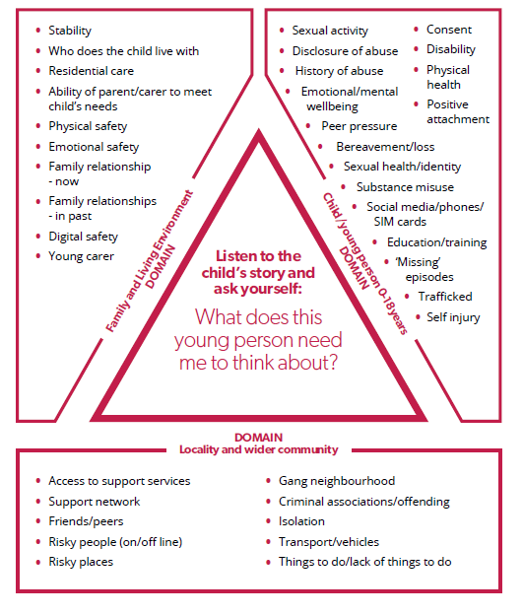
Figure 1.1

  - Outline of the reasons that have resulted in this CSE Framework being completed

  - CHILD/YOUNG PERSON DOMAIN
Please comment on the relevant areas linked to the child/young person’s domain. Consider what creates the child’s vulnerability? Is there any evidence of child is being trafficked for the purposes of sexual exploitation? What positive relationships and/or activities have you identified or are there any that could be developed?

Trafficking in persons’ shall mean the act of: Recruitment, Transportation, transfer, harbouring or receipt of persons. By means of: Threat, use of force, coercion, abductions, fraud, deception and abuse of power for the purpose of exploitation For more information in respect of Trafficking, please refer to the Warwickshire Safeguarding Trafficking procedures.

  - What do you need to know more about?

  - FAMILY AND LIVING ENVIRONMENT DOMAIN
Please comment on the relevant areas linked to the Family and Living Environment domain. Consider the impact of the child’s family environment on their needs and vulnerability. Consider protective factors that exist or need developing?

  - What do you need to know more about?

  - LOCALITY AND WIDER COMMUNITY DOMAIN
Please comment on the relevant areas linked to the Family and Living Environment domain. Consider how do people, locations and other factors in the locality and wider community impact on the child’s needs and vulnerability? Consider protective factors that exist or need developing?

  - What do you need to know more about?

  - Child/Young Person views about the concerns

  - Parents/ Carer views about the concerns

- Assessment

What does this information tell me?

- Additional Information

Please use this box to expand on any additional information.

- Outcome

Based on the assessment above, please provide your professional opinion of risk or harm by selecting ONE of the boxes below (please also tick if there is evidence of other forms of exploitation and give details).

Each outcome has possible next actions identified, however if in doubt, please consult with the Multi-agency Safeguarding Hub (MASH) to seek advice/ consultation.

CSE currently not a factor at this time/concerns relate to age appropriate behaviours

- No further action required.

Evidence of vulnerability to sexual exploitation

  - Consider providing Early Help/ Targeted Services to address the concerns
  - Consult with the MASH for advice about Early Help.

Evidence of being groomed or targeted for the purposes of sexual exploitation

- Refer to the MASH, if the child does not have an allocated worker. Ensure a copy of this CSE Assessment Framework is shared.
- If there is an allocated worker, share concerns and ensure a copy of this CSE Assessment Framework is shared.
- If there is information relating to perpetrators- share with MASH/ Allocated worker
- Share information/ concerns with the Police using the Police Intel Sharing Form

Evidence¹ that child is being sexually exploited

- In the event that the child is in danger or you need an immediate police response, call 999.
- Refer to the MASH, if the child does not have an allocated worker. Ensure a copy of this CSE Assessment Framework is shared.
- If there is an allocated worker, share concerns and ensure a copy of this CSE Assessment Framework is shared.
- If there is information relating to perpetrators- share with MASH/ Allocated worker
- Share information/ concerns with the Police using the Police Intel Sharing Form

Please tick the box below if you have identified evidence of other forms of exploitation

Evidence¹ of other form(s) exploitation e.g. drug trafficking, trafficking, modern day slavery, county lines

- In the event that the child is in danger or you need an immediate police response, call 999.
- Refer to the MASH, if the child does not have an allocated worker. Ensure a copy of this CSE Assessment Framework is shared.
- If there is an allocated worker, share concerns
- If there is information relating to perpetrators- share with MASH/ Allocated worker
- Share information/ concerns with the Police using the Police Intel Sharing Form

- Additional resources:
Warwickshire Police- Intel Form
Warwickshire Police have devised a process by which can provide information about perpetrators and concerns of Child Sexual Exploitation occurring THAT IS NOT AN EMERGENCY AND DOES NOT REQUIRE IMMEDIATE ACTION (in these cases ring 999 or 101).

A copy of this form is available on Warwickshire Safeguarding procedures and by accessing the following link.
Multi-Agency Safeguarding Hub
Further advice and guidance can be provided by the Multi-agency Safeguarding Hub (MASH):

Phone: 01926 414144
Email: mash@warwickshire.gcsx.gov.uk

Please ensure that a copy of the completed assessment document is sent to the above email address when making a referral.

You can also contact the MASH to seek support around Early Help.

Training

Please visit the Warwickshire County Council WILMa site if you would like to find out more about CSE and Trafficking training in Warwickshire.

Something’s Not Right
Please click here to find out more information about Warwickshire’s CSE awareness campaign.

On the balance of probability (more likely than not).
Trafficking in persons’ shall mean the act of: Recruitment, Transportation, transfer, harbouring or receipt of persons. By means of: Threat, use of force, coercion, abductions, fraud, deception and abuse of power for the purpose of exploitation For more information in respect of Trafficking, please refer to the Warwickshire Safeguarding Trafficking procedures.

