Individual Exploitation Assessment Tool

Purpose of tool –

This assessment tool is designed to be used where exploitation is the only or main identified risk factor and the individual is not eligible for care and support services under the Care Act 2014.

This will be completed as one outcome of a MAACE meeting when the Adult Exploitation Screening tool has identified that an individual is being exploited or is at risk of exploitation and a plan has been developed using the contextual safeguarding tool.

Principles of engagement and assessment:

The following principles underpin effective assessment and promote the engagement of young people / adults and their families / carers in the assessment process:

Assessments should: | Individuals:
- be holistic in approach, examining risk and protective factors and addressing the individual’s needs within their family / living environment, their peer group / associates, their educational provision / employment and wider community neighbourhood.  - understand the unique needs of each individual and avoid a ‘one size fits all’ assumptions about different groups.  - adopt a broader perspective than cases of intra-familial abuse and should not be limited to an assessment of parental / carer capacity  - recognise that grooming can cause a breakdown in the protective ability of parents / carers.  - be underpinned by professional curiosity and not simply rely on checklists, disclosures or what is or is not known. If something is not known, professionals should not assume that may not happening.  - provide an analysis of the information gathered, drawing on professional judgement.  - consider the impact of the issues identified in the assessment of the individual and identify the support that is required to meet their needs.  - focus on outcomes, not process.  - avoid any suggestion of judgement or blame in respect of either the individual or their parent/carer. | - should be actively engaged in the assessment process. Individuals who have been abused have already experiences a loss of control and the assessment process should be managed so they can meaningfully participate.  - will require time to develop trust and relationships that underpin effective assessment; assessment should therefore be an ongoing process and individuals should feel like you have all the time they need.  - should be afforded the opportunity to tell their story rather than respond to a series of questions i.e. assessments should happen through conversation rather than as a response to a list of questions.  - should be told that you are worried about them and why; this will help them to understand that you will take seriously any information that they do share.  - should be asked what is happening rather than being told what you think is happening.  - should receive a comprehensive explanation as to what will happen with the information gathered

Adult’s details
First name | Click or tap here to enter text. | Surname |  |  | Click or tap here to enter text.
Date of birth | Click or tap here to enter text. | Ethnicity |  |  | Click or tap here to enter text.
Health conditions | Click or tap here to enter text. | Communication needs |  |  | Click or tap here to enter text.
Address | Click or tap here to enter text. | Postcode |  |  | Click or tap here to enter text.
Was a screening tool completed? |  |  | Yes | ☐ |  | No | ☐
Has a MAACE meeting been convened? |  |  | Yes | ☐ |  | No | ☐
Has an NRM/Duty to Notify referral been made? |  |  | Yes | ☐ |  | No | ☐
Details of current support and services in place
Click or tap here to enter text.
Carer / representative’s details (if applicable)
First name | Click or tap here to enter text. | Surname |  |  | Click or tap here to enter text.
Relationship | Click or tap here to enter text. | Contact details |  |  | Click or tap here to enter text.
First name | Click or tap here to enter text. | Surname |  |  | Click or tap here to enter text.
Relationship | Click or tap here to enter text. | Contact details |  |  | Click or tap here to enter text.
Details of the person completing the assessment
First name | Click or tap here to enter text. | Surname |  |  | Click or tap here to enter text.
Role | Click or tap here to enter text. | Organisation |  |  | Click or tap here to enter text.
Telephone number | Click or tap here to enter text. | Email address |  |  | Click or tap here to enter text.
Date Assessment started | Click or tap here to enter text. | Date Assessment completed |  |  | Click or tap here to enter text.
Agencies contributing to the assessment
First name | Click or tap here to enter text. | Surname |  |  | Click or tap here to enter text.
Role | Click or tap here to enter text. | Organisation |  |  | Click or tap here to enter text.
Telephone number | Click or tap here to enter text. | Email address |  |  | Click or tap here to enter text.
Date of contribution | Click or tap here to enter text.
First name | Click or tap here to enter text. | Surname |  |  | Click or tap here to enter text.
Role | Click or tap here to enter text. | Organisation |  |  | Click or tap here to enter text.
Telephone number | Click or tap here to enter text. | Email address |  |  | Click or tap here to enter text.
Date of contribution | Click or tap here to enter text.
First name | Click or tap here to enter text. | Surname |  |  | Click or tap here to enter text.
Role | Click or tap here to enter text. | Organisation |  |  | Click or tap here to enter text.
Telephone number | Click or tap here to enter text. | Email address |  |  | Click or tap here to enter text.
Date of contribution | Click or tap here to enter text.
Assessment
Outline of the reasons that have resulted in this assessment being completed
Click or tap here to enter text.
Other previous or current assessments? |  |  | Yes | ☐ |  | No | ☐
If yes please provide details |  | Click or tap here to enter text.

Assessment Framework
The diagram below provides a framework to explore the individual’s needs. You will need to work with the individual to consider factors from each of the 3 domains in your assessment. The bullet points are intended to act as a guide to help you respond to the questions in the next section.
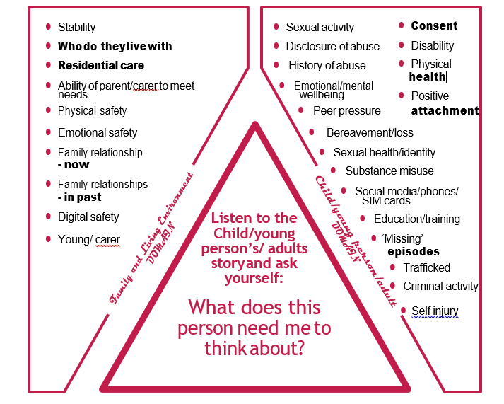
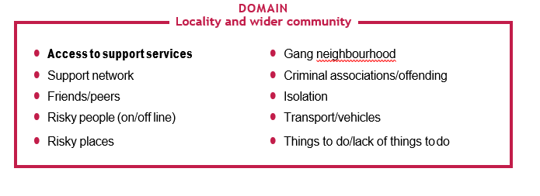
Person Domain
What creates or increases the individual’s  vulnerability? | Click or tap here to enter text.
Do you or anybody else suspect any undiagnosed learning disability? | Click or tap here to enter text.
What evidence, if any is there that the individual is being trafficked? For what purpose? | Click or tap here to enter text.
What positive relationships and / or activities have you identified or are there any that could be developed? | Click or tap here to enter text.
What do you need to know more about? | Click or tap here to enter text.
Family and Living Environment Domain
How does the individual’s family and / or living environment impact on their needs and vulnerability? | Click or tap here to enter text.
What protective factors exist or could be developed in the family and / or living environment? | Click or tap here to enter text.
What do you need to know more about? | Click or tap here to enter text.
Locality and Wider Community Domain
How does the locality and wider community impact on the individuals needs and vulnerability? | Click or tap here to enter text.
What protective factors exist or could be developed in the locality and wider community? | Click or tap here to enter text.
What do you need to know more about? | Click or tap here to enter text.

Questions for the adult
What are your views about the risks? | Click or tap here to enter text.
What would you like in the short and long term future? | Click or tap here to enter text.
What are the family / care’s views about the risks (if appropriate) | Click or tap here to enter text.
What would the family / carers like for the individuals short and long terms future (if appropriate) | Click or tap here to enter text.
Based on the assessment above, please provide professional opinion of risk by selecting
ONE of the boxes below:

No concerns of exploitation |  | Yes | ☐ | No | ☐
Evidence of vulnerability to exploitation |  | Yes | ☐ | No | ☐
Evidence of being groomed or targeted for the purposes of exploitation |  | Yes | ☐ | No | ☐
Evidence that the individual is being exploited |  | Yes | ☐ | No | ☐
Form of exploitation identified |  | ☐ Sexual  ☐ Criminal  ☐ Home invasion  ☐ Forced Labour  ☐ Trafficking  ☐ Domestic Servitude  ☐ Other
Your assessment of the risks the individual faces / any harm they are experiencing and their needs | Click or tap here to enter text.
What information has your assessment identified about other individuals who may be at risk of, or are being exploited? | Click or tap here to enter text.
What information has your assessment identified about alleged perpetrators / suspects? | Click or tap here to enter text.
What information has your assessment identified about risky locations? | Click or tap here to enter text.
Planning – what does the individual need to make them safer and meet their needs in the:
Short Term | Click or tap here to enter text.
Long Term | Click or tap here to enter text.
How will you know that the risks to the individual are reducing? | Click or tap here to enter text.
What support do you need as a professional working with this individual to promote their safety? | Click or tap here to enter text.
Additional Information

