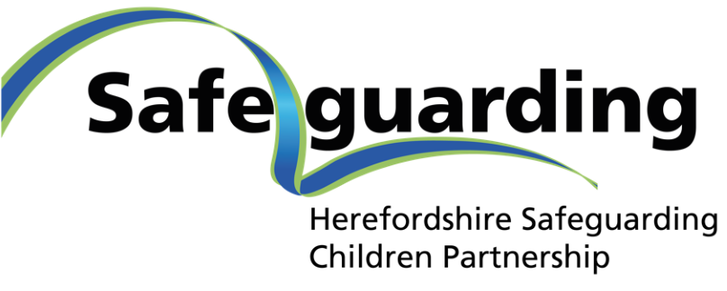

Neglect Strategy (Interim) 2021-2023:

A strategic plan to prevent and reduce child neglect and to ensure the safety and wellbeing of children and young people in Herefordshire.

Version: | Final – V1
Date: | August 2021
Review Date: | March 2023
Document Author: | Herefordshire Safeguarding Children Partnership
Document Owner: | Herefordshire Safeguarding Children Partnership

Contents
1. Background 3
What we know 3
What we want to achieve 3
2. Building a collaborative approach 4
Having a shared understanding and definition 4
Three high-level objectives 4
We will know we have made a difference when: 5
Underpinning principles and values 5
3. National Picture 6
4. The Local Picture 7
The impact of the coronavirus pandemic 8
Young People’s Voices 10
5. Delivery Plan 10
6. Useful Resources 10
7. References………………………………………………………………………… 12

Appendix I: Safeguarding Children & Young People Delivery Plan – Neglect 13
How will we know we have made a difference? 13
How we will achieve this 13
Outcomes for neglect priority 14

Background
In Herefordshire, we are committed to making a difference to the lives of children and young people in our communities. We want Herefordshire to be a great place to be young, where all children and young people thrive and feel safe from harm and neglect.
The Herefordshire Safeguarding Children Partnership (HSCP) has identified neglect as a priority for Herefordshire for 2021/24.
- We will focus on what will make the most difference to improving the lives of our children and young people;
- We will ensure the child and young person is at the centre of all we do.
The strategic aim of the HSCP is to prevent and reduce neglect and to improve the safety and wellbeing of children and young people in Herefordshire. In order to achieve this, it is vital that neglect is prevented, recognised early and that all agencies involved in the care of children in Herefordshire work together and have a consistent, timely and appropriate response to a child considered to be at risk of physical harm, emotional neglect or abuse.
Partners will use the Joint Strategic Needs Assessment (JSNA) to inform the Neglect Delivery Plan to:
- Identify the prevalence, nature and profile of neglect in Herefordshire
- Ensure appropriate actions are taken
- Evidence the impact of supportive interventions

What we know:
- Neglect is a common reason for a child to be the subject of a child protection plan (just over a third of child protection plans, on average, over 8 months 2020/21 in Herefordshire)
- Neglect exposes children to other forms of abuse e.g. child criminal exploitation, increasing their vulnerability
- Neglect can be difficult to identify, making it hard for professionals to take action to protect a child
- National research has highlighted the damage done to children and young people living in situations of neglect. The harm resulting from intentional or unintentional neglect can be especially damaging in the first 18 months of life and can also have a cumulative impact across childhood and into adolescence

What we want to achieve:
In order to create a coherent approach to reducing neglect, we want this strategy to:
- Support practitioners to keep children and young people in Herefordshire safe from neglect
- Enable partners to both challenge and support each other to achieve quality interventions
- Encourage practitioners to be confident to recognise all forms and signs of neglect much earlier in children’s lives
- Develop a well trained workforce, competent in tackling neglect
- Create public awareness so that parents, carers and communities recognise neglect and are empowered to seek advice and support when additional help is needed
- Create a wider, nurturing environment that helps to prevent neglect

Building a collaborative approach
Having a shared understanding and definition of neglect across all services and partners is key to developing and embedding a collective approach through training and practice.
“Neglect is the failure to meet a child’s basic needs. Neglect can happen over a period of time, but can also be a one-off event. Incidents often don’t meet social care or criminal thresholds: it is the cumulative effect that is most impactful. A child may be left hungry or dirty, without adequate clothing, shelter, supervision, medical or health care.
A child may be put in danger or not protected from physical or emotional harm. They may not get the love, care and attention they need from their parents. A child who is neglected will often suffer from other abuse as well, both inside and outside of the home. Neglect is dangerous and can cause serious, long-term damage - even death.”
Source: Child Neglect, Be Professionally Curious! Action for Children (2016).
In addition, Working Together to Safeguard Children (2018) highlights that “children may be vulnerable to neglect and abuse or exploitation from within their family and from individuals they come across in their day-to-day lives. These threats can take a variety of different forms, including: sexual, physical and emotional abuse; neglect; domestic abuse, including controlling or coercive behaviour; exploitation by criminal gangs and organised crime groups; trafficking; online abuse; sexual exploitation and the influences of extremism leading to radicalisation. Whatever the form of abuse or neglect, practitioners should put the needs of children first when determining what action to take.”
Three high-level objectives have been identified to take forward this whole-system approach to preventing and reducing neglect. These are supported by key actions and outcomes and underpinned by shared values and principles across the Safeguarding Partnership and partner agencies.
- Multi-agency strategic leadership prioritises tackling child neglect in Herefordshire.

- Use the Joint Strategic Needs Analysis (JSNA) to understand the nature/profile of neglect to inform the neglect strategy and delivery plan to:
- identify prevalence, nature and profile of neglect
- know we have the right actions
- evidence the impact of supportive interventions.

- To implement professional development resources to support practitioners; and community resources to engage with and build community resilience to effectively identify and tackle child neglect, and support families.

We will know we have made a difference when:
- Parents and carers report they know how to seek advice and support
- Parents and children/young people say early help services have made a positive difference to their lives
- Through assessment, parents/carers, children and professionals identify what is working well and what needs to change
- Plans to provide support set out clearly what needs to change and how the change will be measured
- Staff are confident to recognise all forms of neglect
- Children and young people who are suffering neglect are identified early (at the right time); the right help and support is in place
- A robust multi-agency dataset provides a comprehensive basis from which to identify local patterns of neglect and address any new and emerging themes
- Information, training and awareness delivered to professionals around identifying and understanding neglect helps professionals identify neglect at the earliest opportunity and ensure early safeguarding intervention/s are in place

Underpinning principles and values
This strategy is underpinned by the following principles and values:
- A shared understanding of neglect and that the safety and wellbeing of children and young people is a priority
- A shared understanding of the consequences of neglect and effects on a child’s health, safety and development including the impact of emotional neglect – taking an ACEs/trauma-informed approach
- Prevention and early recognition of neglect followed by timely assessment and intervention using a strengths based approach (Signs of Safety)
- Clarity over thresholds of need and distinctions between, for example, emerging circumstantial neglect or persistent neglect causing significant harm
- A uniform, consistent and integrated approach from all agencies and effective collaboration between them including effective information sharing
- An early help approach to improve the safety of children and young people, ensuring a variety of appropriate interventions to tackle child neglect and place this within an approach that prioritises contextualised safeguarding – ‘Right Help; Right Time’ is a Safeguarding Partnership priority
- All agencies have a role in prevention and signposting support and education for parents and carers, such as the Solihull Approach online parenting programme
- Recognition of the overlap between neglect and other forms of child maltreatment such as domestic abuse and substance misuse etc.
- Recognition that child exploitation is an increasing area of threat linked to neglect, encompassing sexual and economic exploitation, for example, county lines activity – child exploitation is a priority for the Safeguarding Partnership
- Recognition that children with special educational needs and disabilities are potentially more vulnerable
- Ensuring that a ‘whole family approach’ underpins how services work with children and their families and this approach is adopted by all stakeholders
- Routine assessment of progress made by families and work with children and young people to be measured by impact on outcomes, rather than processes and services involved
- Appropriate statutory action to be taken if sufficient progress has not been made and existing support and intervention have not been successful in addressing the level of risk present
- Professionals must be “professionally curious” and ask “the second question.” They need to feel confident to challenge families and each other about understanding the situation and the sustainability of any improvements required. Historical information must be considered to inform the present position and identify families at risk of intergenerational neglect.
- The views of ‘service users’ must be taken into consideration and lessons should be learned from experiences of families, children and young people living with neglect
- The key aim for the practitioner working with neglect is to enable and ensure a healthy living environment which in turn enables healthy relationships for children

National Picture
National learning from case reviews in which a child has been seriously or fatally injured, highlights the following key features (NSPCC, Sept 2015 and NSPCC 2021):
- Professionals must understand and recognise physical and emotional neglect, and the impact of cumulative and long-term effects of neglect
- In cases where practitioners worked with families over a long period of time, or where families were hostile to intervention, a need was identified for safe spaces in which practitioners could discuss cases and explore concerns. Cases where a lack of professional curiosity was highlighted included those involving:
  - adolescents – leading to a focus on ‘troubling’ behaviour, rather than the causes of the behaviour
  - babies – leading to acceptance of explanations for injuries which were incompatible with babies’ stage of development
  - fathers and men in families – leading to a lack of consideration of men’s capacity to provide care or support to their families, as well as any risks they might pose
  - minority ethnic groups – leading to a lack of consideration of how ethnicity or cultural background might impact on parenting style, beliefs and interaction with the wider community
- Teenagers can be missed; especially where there are younger children in the home
- Tooth decay can indicate neglect
- Systems should be in place to monitor missed appointments and professionals should know what to do when there are concerns
- Frequent accidents may indicate poor quality parenting; frequent visits to A&E should cause concern
- Maintain a focus on the best interests for the child rather than the immediate needs of the parent who may be demanding
- Improvements to home conditions should be regularly reviewed to ensure they are sustained
- Be aware of the possibility of disguised compliance and respectfully challenge when they fail to follow agreements
- See the bigger picture and take account of family history
- Undertake robust and comprehensive assessments and actively review these
- Use supervision to avoid case drift
- Inter-agency communication and information sharing should be reviewed regularly. Barriers to sharing information between safeguarding partners were highlighted in almost half of all reviews (2021). Issues included: relying on other agencies to make referrals, not valuing information from third sector organisations, different IT systems and difficulties around what to share, when and how.
The NSPCC analysed police data for the UK over a 5 year period to 2019. In 2013/14 there were 9,518 child cruelty and neglect offences recorded by police forces. By 2018/19 this had more than doubled to 20,024 crimes of this nature (NSPCC, November 2019).

The Local Picture
Herefordshire is home to around 35,900 young people aged under 18 and this is projected to increase to 37,000 by 2025. Children in Herefordshire generally receive a good education, however this does not necessarily translate into social mobility. Our children and young people are less likely to experience the well-publicised threats of knife crime and gang culture than their counterparts in Britain’s urban centres, but growing up in one of England’s most rural counties presents issues of its own.
Action with Communities in Rural England (ACRE) has, for example, highlighted how “for many children and young people, the ‘rural idyll’ of living in the countryside is far from reality. There are no cinemas, clubs, or other facilities their counterparts in urban areas take for granted. This isolation from services is often made worse by a lack of transport options and hidden poverty.”
In addition, despite relatively abundant active leisure opportunities, children in Herefordshire are no less likely to be overweight or obese than their peers in England as a whole. The oral health of children in Herefordshire is also consistently poor compared to the rest of England.
The Herefordshire Child Health Profile, compiled by Public Health England, concludes that:
“overall, comparing local indicators with England averages, the health and wellbeing of children in Herefordshire is mixed.
The infant mortality rate is similar to England with an average of 9 infants dying before age 1 each year. Recently there have been 4 child deaths (1-17 year olds) each year on average.
The teenage pregnancy rate is similar to England, with 36 girls becoming pregnant in a year.
Dental health is worse than England. 31.9% of 5 year olds have experience of dental decay.
Levels of child obesity are similar to England. 10.1% of children in Reception and 19.2% of children in Year 6 are obese.
The rate of child inpatient admissions for mental health conditions at 249.7 per 100,000 is worse than England. The rate of self-harm (10-24 years) at 482.1 per 100,000 is similar to England.
The percentage of young people aged 16 to 18 not in education, employment or training is worse than England at 9.2%.
54 children per year received their first reprimand, warning, or conviction. This gives a rate which is worse than England.”
In addition, 17.2% of children under 16 in Herefordshire are living in poverty (most recent data available 2018/19). PHE Herefordshire Child Health Profile, March 2021.
School readiness, good level of development at end of Reception year (overall) is 75.4% (2018/19), which is an increase on the previous year. PHE High Impact Areas data June 2021.
In terms of identifying neglect, childhood obesity and poor oral health, need to be recognised as potential indicators and will be included within the delivery plan.
In Herefordshire, in 2019/2020, 38% of children on a Child Protection Plan were identified with neglect. In 2020/21 (July to Feb latest figures), 35% of children on a Child Protection Plan were identified with neglect.

The impact of the coronavirus pandemic
The NSPCC commissioned work to consider the impact of lockdown on social isolation and child mistreatment and identified some key issues which resonate locally.
“For most children and young people, this last year has been the longest stretch of time in their lives spent away from friends and trusted adults outside the home. The impact of lockdown on children’s emotional and mental health, combined with almost full-time confinement in their homes and changes to their routines, has created new vulnerabilities and exacerbated existing ones. Young people with digital access are spending more time using social media and online resources: this increases the risk that they may experience online-facilitated grooming or other online harms, during a period when demand for online child sexual material is known to be on the rise. For children who are already experiencing abuse or neglect by household members, confinement at home has meant prolonged exposure to potential harm.”
Isolated and Struggling: Social isolation and the risk of child maltreatment, in lockdown and beyond, NSPCC, June 2020
“Not being able to meet face to face presented issues for the provision of and engagement with services and the efficacy of risk assessments. Changes to services also presented some positive opportunities, including: telephone calls providing a less intimidating alternative to face-to-face appointments; non-attendance at school providing opportunities for agencies to visit vulnerable young people at home; and the scaling back of social care home visits leading to improved interagency working as social workers relied on other agencies to be their ‘eyes’ on children.
The pandemic also had a significant impact on the lives of families and children, including: feelings of isolation during lockdown and agitation once restrictions were lifted, challenges balancing childcare and work, lack of support and monitoring by social networks, delays in seeking support because of fear of infection, and financial issues.”
A summary of the annual review of Local Child Safeguarding Practice Reviews and rapid reviews, NSPCC, May 2021
The partnership will ensure that the impacts of the pandemic are recognised and actions taken to minimise longer-term effects, where practically possible, through enhanced service provision and/or restoration of services.

Young People’s Voices
Capturing the voices, feelings and experiences of children and young people will be vital in terms of assessing impact and outcomes. These are some of the experiences of young people reflected back to us when asked about how we could do things better:

We need people round us that we can trust
“Don’t make us talk to you about stuff in front of other people, take us somewhere private so we can express ourselves properly”

Stability is very important to help young people to go on to lead good lives, despite what they lived through

Delivery Plan (see Appendix 1)
Note this Neglect Strategy and subsequent Delivery Plan are owned by HSCP and overseen by the HSCP Child Neglect Strategic Group.

Useful Resources
- Right Help Right Time – Levels of Need (2020): Right Help Right Time Levels of Need Framework 2020_1.pdf (procedures.org.uk)
- Early Help Strategy (Draft 2021-2024 updated 2021): Early Help strategy – Herefordshire Council
- ACEs: See Childhood trauma | Blackburn with Darwen Borough Council
- Spotting the Signs of Neglect
Neglect can be difficult to spot, particularly if you see only one of the signs. There may be several signs that last over a period of time that might indicate a serious problem, for example:
- Poor appearance and hygiene
- Health and development problems
- Housing and family issues
- Changes in behaviour
See Neglect is also Child Abuse: Know All About It | NSPCC
- Classifications of neglect identify neglect under a number of category headings: medical, nutritional, emotional, educational, physical and lack of supervision (ref Jan Horwath): Experiences of neglect by Howarth's classifications - A3 Poster.pdf (suttonlscp.org.uk)
- Escalation of professional differences: Escalation policy: Resolution of professional disagreements (procedures.org.uk)
- Solihull parenting training and online resources: Solihull Approach | inourplace | Understanding your child
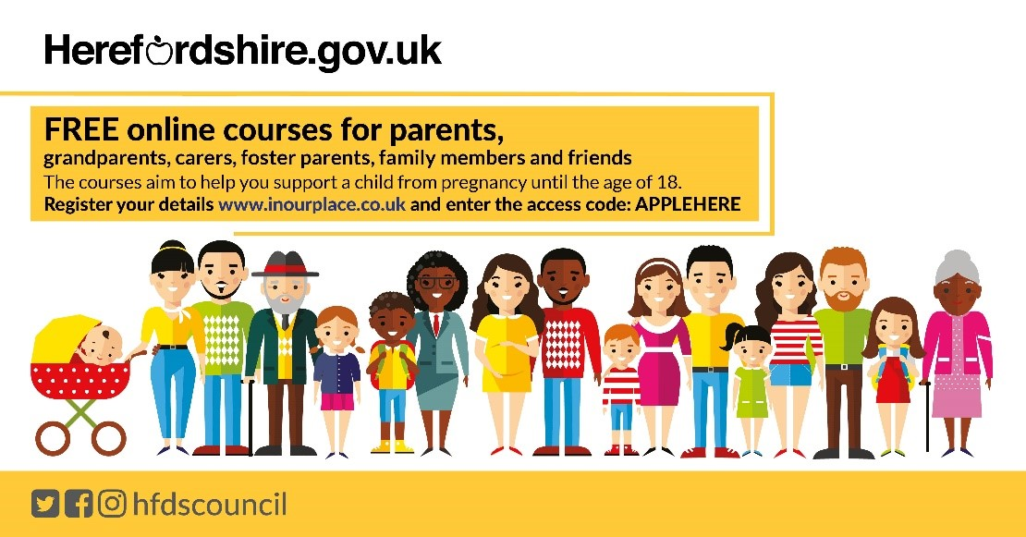

References
Child Neglect, Be Professionally Curious! Action for Children (2016): https://www.actionforchildren.org.uk/search-results/?SearchTerm=neglect
Child maltreatment: when to suspect maltreatment in under 18s. Clinical guideline [CG89] Published date: 22 July 2009. Last updated: 09 October 2017: https://www.nice.org.uk/guidance/cg89/chapter/1-Guidance
Dudley Safeguarding People Neglect Strategy: https://safeguarding.dudley.gov.uk/safeguarding/child/work-with-children-young-people/neglect-strategy/
NSPCC:
https://www.nspcc.org.uk/globalassets/documents/advice-and-info/neglect-matters.pdf
https://learning.nspcc.org.uk/media/2590/annual-review-lcsprs-rapid-reviews-summary.pdf
Cheshire West Strategy: https://www.cheshirewestscp.co.uk/wp-content/uploads/2018/10/Cheshire-West-Neglect-Strategy-2017-20-Final.pdf
Working together to Safeguard Children (2018): https://assets.publishing.service.gov.uk/government/uploads/system/uploads/attachment_data/file/779401/Working_Together_to_Safeguard-Children.pdf
Herefordshire Children and Young People’s Partnership Plan: https://www.herefordshire.gov.uk/downloads/file/18581/herefordshire_children_and_young_peoples_plan_2019-2024.pdf
West Midlands Safeguarding Children Policies and Procedures: https://westmidlands.procedures.org.uk/page/contents
Action for Communities in Rural England: https://acre.org.uk/rural-issues/young-people
Obesity and Neglect:
https://www.norfolklscb.org/wp-content/uploads/2015/04/Safeguarding-Response-to-Obesity-when-Neglect-is-an-Issue-Guidance.pdf
https://www.suffolksp.org.uk/assets/2020-01-08-Safeguarding-Response-to-Obesity-when-Neglect-is-an-Issue.pdf
Dental / Oral Health and Neglect: https://www.rcpch.ac.uk/sites/default/files/2019-09/child_protection_evidence_-_dental_neglect.pdf
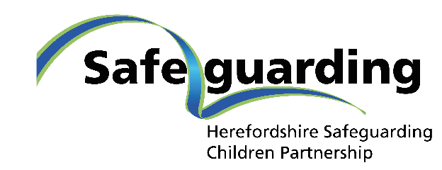

Appendix I: Safeguarding Children & Young People Delivery Plan – Neglect

Aim - We aim to recognise, prevent and reduce neglect to improve the safety and wellbeing of children and young people in Herefordshire.

How will we know we have made a difference?
- Parents and carers report they know how to seek advice and support
- Parents and children/young people say early help services have made a positive difference to their lives
- Through assessment, parents/carers, children and professionals identify what is working well and what needs to change
- Local communities have an awareness and understanding of neglect and can identify local champions to prevent neglect and signpost support
- Plans to provide support set out clearly what needs to change and how the change will be measured
- Staff are confident to recognise all forms of neglect
- Children and young people who are suffering neglect are identified early (at the right time); the right help and support is in place
- A robust multi-agency dataset provides a comprehensive basis from which to identify local patterns of neglect and address any new and emerging themes
- Information, training and awareness delivered to professionals around identifying and understanding neglect helps professionals identify neglect at the earliest opportunity and ensure early safeguarding intervention/s are in place

How we will achieve this

Objective 1 – Multi-agency strategic leadership is in place to tackle child neglect in Herefordshire.
Actions:
- Neglect Strategy developed by the HSCP
- Neglect Strategy delivery plan agreed and implemented by a multiagency group that reports to the Safeguarding Partnership
- Systematic approach to addressing the impacts of the coronavirus pandemic to be identified
- Neglect Strategy and delivery plan is promoted across the Safeguarding Partnership so that agencies are aware of their role in tackling neglect in Herefordshire

Objective 2 – Develop a Multi-agency dataset that highlights the prevalence of neglect and assesses the interventions put in place to support children and families who have experienced neglect.
Actions:
- Multi-agency neglect case audits carried out
- Multi-agency neglect referral data collected
- Neglect scorecard providing a comprehensive record and analysis of neglect data and interventions across Herefordshire produced to inform strategy and practice
- Ensure that reporting is robust and clearly identifies the correct need of the child

Objective 3 – To put in place professional development resources to support practitioners to effectively identify and tackle child neglect, and support families.
Actions:
- Multi-agency training provided regularly throughout the year
- An integrated approach to training to be developed to reflect a multi-agency approach to collaboration e.g. Signs of Safety, Trauma-informed practice/ACEs training
- Signs of neglect and pathways reflecting the links between obesity and neglect and poor dental health and neglect to be developed
- Online multi-agency neglect awareness raising course developed and rolled out
- Neglect webpages produced to support professional learning and understanding of neglect on the Safeguarding Partnership website
- Prevention and parenting support to be available through training and online and promoted to parents e.g. Solihull Approach

Outcomes for Neglect Priority
- Children are kept safe from neglect because Herefordshire is following a clear, systematic, multi-agency strategic approach to tackling child neglect in Herefordshire
- Partner agencies are held to account for their performance and quality of interventions with regard to neglect
- The Safeguarding Partnership understands the prevalence and causes of neglect in Herefordshire through our links with other Boards, Partnerships and Groups
- The impact of long term neglect is reduced because children and young people who are living with neglect are identified early and the right help is put in place at the right time
- The Herefordshire safeguarding workforce is skilled, prepared, well trained and works effectively with others to reduce child neglect in Herefordshire

Document Classification
Author Name & Role | Herefordshire Safeguarding Children Partnership
Date Created | August 2021
Date Issued | October 2022
Description | A strategic plan to prevent and reduce child neglect and to ensure the safety and wellbeing of children and young people in Herefordshire.
File Name | Neglect Strategy (Interim) 2021-23
Format | Word Document
FOI/EIR Disclosure
Geographical Coverage | Herefordshire
Group Access
Language | English
Master Location | West Midlands Procedures
Publisher | Herefordshire Safeguarding Children Partnership
Rights Copyright | Herefordshire Safeguarding Children Partnership
Security Classification | Not classified
Subject | Child neglect, child protection, safeguarding
Type | Local Strategy
Consultation Log
Date sent for Consultation | 2021
Consultees | HSCP Neglect Sub-Group
Approval Log
To be agreed by | HSCP Neglect Sub-Group
To be approved by | HSCP Executive Support Group / Strategic Partners Board
To be reviewed by | HSCP Neglect Sub-Group
Review date: | March 2023
Version Log
Version | Date | Description of change | Reason for Change
Version 1 | October 2022 | This is the first version of the Neglect Strategy published. This is an interim strategy, with plans to review March 2023.

