**If a child is at imminent significant risk of harm/immediate danger, call 999**. Then contact children’s social care via **Sandwell Contact Centre** on **0121 569 3100 (24 Hours).** You will also be expected to complete a MARF following this contact.

If the child is in no immediate danger but you have child protection concerns you must **complete a MARF as soon as possible** and within a maximum of 24 hours.

Send the MARF via secure email to [Access_Team@sandwellchildrenstrust.org](mailto:Access_Team@sandwellchildrenstrust.org) with the **subject title MARF** (for those agencies who do not have secure email, please password protect the MARF prior to sending, and telephone **Sandwell Contact Centre** to advise them of the password).

We appreciate that different agencies may not have access to all the information required to complete all sections of the MARF, it is your responsibility to provide **all the information available to you at the time of making the referral.**

For guidance on completing the MARF please see the accompanying **Sandwell MARF Guidance** and **Multi-Agency Threshold** documents.

|  |  |  |  |  |  |  |  |  |  |  |
| --- | --- | --- | --- | --- | --- | --- | --- | --- | --- | --- |
| **Consent:** | | | | | | | | | | |
| Are parents/carers aware that this referral is being made? | Yes | √ | No |  | | Written/Verbal | | |  | |
| Has consent been obtained from the parent/carer to share this information? | Yes |  | No | √ | | Written/Verbal | | |  | |
| If consent has NOT been obtained, please record the reason/s for this (Parent/carer consent should only be sought if it will not put the child at further risk. If there is a Child Protection concern, this MARF should still be sent without parent/carer consent.):  Consent was requested but mother refused stating she didn’t see why it needed referring. Reason for referral explained to mother (see main concern) | | | | | | | | | | |
| Do you consider the child/young person to be at **IMMEDIATE RISK OF HARM**? | | | | | Yes | |  | No | | √ |

|  |  |  |  |  |
| --- | --- | --- | --- | --- |
| **Advice Prior to Completing MARF:** | | | | |
| Have you discussed this referral with a professional outside of your organisation e.g. a duty Social Worker/COG Worker? | Yes | √ | No |  |
| If yes, please provide the name/job title of the Professional? | Perry Reid – EH social worker at the COG. | | | |

|  |  |  |  |  |  |  |  |
| --- | --- | --- | --- | --- | --- | --- | --- |
| **Child/Young Person’s Details:** | | | | | | | |
| **Forename(s):** | Roisin | **Surname:** | McManus | | | | |
| **Address:** | 1 Cherry Apple Road  Sandwell  Bxxxx | | | | | | |
| **Home Telephone:** | xxxxxxxx | **Mobile Telephone:** | xxxxxxxx | | | | |
| **Date of Birth:** | Xxxxxx  aged 14 years 1 month | **Gender:** | Male |  | Female | | √ |
| **Estimated Due Date if unborn baby/hospital where booked:** | | |  | | | | |
| **Ethnic Origin:** | **White British** | **Disability:** | None | | | | |
| **NHS Number:** | Xxxxxxxxx | **Religion:** | Catholic | | | | |
| **First Language:** | English | **Interpreter Required?** | Yes |  | No | √ | |
| **GP Address/ Contact Number** | Dr Watson  Health Surgery  Jogging Road  Sandwell | | | | | | |
| **Nursery/ School / Children’s Centre Address / Contact Number** | Learnwell School  Education Road  Sandwell  xxxxxxxxx | | | | | | |
| **To assist with identifying the correct child/young person requiring the assessment, please include a description of the child’s physical characteristics: e.g. Colour of Eyes, Hair and Skin, Length of Hair, Approx. Height/Weight and any distinguishing marks:** | | | | | | | |
| White, pale skinned  Height 5ft 2 ins  Slim Build  Light Brown hair  Freckles  Pale blue eyes  Ears pierced twice in each ear and nose piercing to right side of nose | | | | | | | |

|  |  |  |  |  |  |  |
| --- | --- | --- | --- | --- | --- | --- |
| **Parent/Carer Details: Person 1** | | | | | | |
| **Forename(s):** | Claire | **Surname:** | Studwell | | | |
| **Address (if different from Child’s address):** | Same as child’s | | | | | |
| **Home Telephone:** | xxxxx | **Mobile Telephone:** | xxxxxx | | | |
| **Date of Birth:** | xxxxx | **Relationship to child:** | xxxxx | | | |
| **Ethnic Origin:** | White British | **Disability:** | None recorded | | | |
| **First Language:** | English | **Interpreter Required?** | Yes |  | No | √ |
| **Do they have parental responsibility?** | | | Yes | √ | No |  |
| **Parent/Carer Details: Person 2** | | | | | | |
| **Forename(s):** | Connor | **Surname:** | McManus | | | |
| **Address:** | HMP Hewell Grange  Redditch | | | | | |
| **Home Telephone:** | xxxxxxx | **Mobile Telephone:** | xxxxxx | | | |
| **Date of Birth:** | xxxxx | **Relationship to child:** | xxxxxxx | | | |
| **Ethnic Origin:** | White Irish | **Disability:** | None recorded | | | |
| **First Language:** | **English** | **Interpreter Required?** | Yes |  | No | √ |
| **Do they have parental responsibility?** | | | Yes | √ | No |  |
| **Significant Others: e.g. Grandparents** | | | | | | |
| **Forename(s):** | Ryan | **Surname:** | Studwell | | | |
| **Address:** | Same as child’s | | | | | |
| **Home Telephone:** | xxxxxx | **Mobile Telephone:** | xxxxxx | | | |
| **Date of Birth:** | xxxxxx | **Relationship to child:** | Step father | | | |
| **Significant Others: e.g. Grandparents** | | | | | | |
| **Forename(s):** |  | **Surname:** |  | | | |
| **Address:** |  | | | | | |
| **Home Telephone:** |  | **Mobile Telephone:** |  | | | |
| **Date of Birth:** |  | **Relationship to child:** |  | | | |

|  |  |  |  |  |  |  |  |
| --- | --- | --- | --- | --- | --- | --- | --- |
| **Other Household Members:** | | | | | | | |
| **Individual 1:** | | | | | | | |
| Forename: | Callum | Surname: | Studwell | DOB: | | Xxxxx 17 years 2 months | |
| Relationship | Brother | Was this individual also referred? | | Yes |  | No | √ |
| **Individual 2:** | | | | | | | |
| Forename: | Abbey | Surname: | Studwell | DOB: | | Xxxx 8 years 4 months | |
| Relationship | Half - Sister | Was this individual also referred? | | Yes |  | No | √ |
| **Individual 3:** | | | | | | | |
| Forename: | Jacob | Surname: | Studwell | DOB: | | Xxxx 2 years 6 months | |
| Relationship |  | Was this individual also referred? | | Yes |  | No |  |
| **Individual 4:** | | | | | | | |
| Forename: |  | Surname: |  | DOB: | |  | |
| Relationship |  | Was this individual also referred? | | Yes |  | No |  |
| **Individual 5:** | | | | | | | |
| Forename: |  | Surname: |  | DOB: | |  | |
| Relationship |  | Was this individual also referred? | | Yes |  | No |  |
| **Individual 6:** | | | | | | | |
| Forename: |  | Surname: |  | DOB: | |  | |
| Relationship |  | Was this individual also referred? | | Yes |  | No |  |

|  |  |  |  |  |  |  |
| --- | --- | --- | --- | --- | --- | --- |
| **Details of Referrer:** | | | | | | |
| Name: | Caron Smith | | | | | |
| Organisation and Job Title: | Learnwell school – Designated Safeguarding Lead Officer | | | | | |
| Relationship to child: | Professional | | | | | |
| Address:  (Including Postcode) | Learnwell School  Education Road  Sandwell  xxxxxxxxx | | | | | |
| Telephone No: | xxxxxxx | Mobile No: | | xxxxxxxxxx | | |
| Email Address: | csmith@learnwell.org | | | | | |
| **Please provide an alternative contact to whom information can be fed back to if the referrer is not available, or cannot be contacted e.g. Line Manager, Designated Safeguarding Lead:** | | | | | | |
| Name: | Richard Legge | | | | | |
| Organisation and Job Title: | Learnwell school – Head teacher | | | | | |
| Telephone No: | xxxxxxxxxx | Mobile No: | | xxxxxxxxx | | |
| Email Address: | Rlegge@learnwell.org | | | | | |
| **For Hospital Staff:** | | | | | | |
| Has the child/young person been - | | Admitted |  | | Discharged |  |
| Where has the young person been admitted or discharged to? (E.g. Ward/Hospital/Home). | |  | | | | |

|  |  |  |  |
| --- | --- | --- | --- |
| **Are you aware of any other agencies currently involved e.g. School Nurse, CAMHS, YOS** | | | |
| Name: | Organisation and Job Title: | Email Address: | Telephone: |
| Miranda Moore | School Health nurse service | MirandaM@SHN.org | xxxxxxxxxx |
|  |  |  |  |
|  |  |  |  |

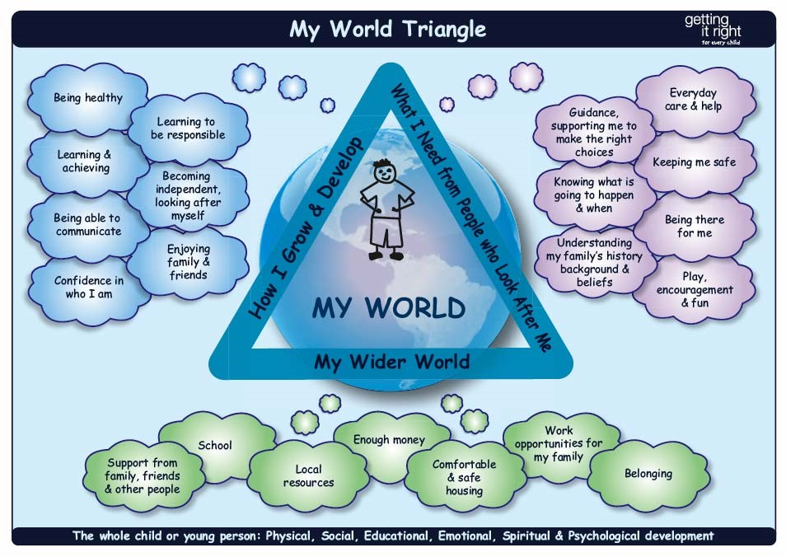

|  |  |  |  |  |  |  |
| --- | --- | --- | --- | --- | --- | --- |
| **Presenting Concerns: (Please describe the incident or circumstances that have led to a referral being made, including the date the child was last seen)** | | | | | | |
| Rosin has presented at school today very upset which is the second time in a week. The first time she thought she may be pregnant but she has now done a pregnancy test and it is confirmed.  When I tried to discuss things with her yesterday when she first told me she may be pregnant she refused to say anything more and would not answer questions. I advised her to discuss things with her mother and perhaps do a test. I sought advice from the COG social worker who advised to speak to Roisin and her mother but it would need a referral.  When Rosin came in today she was more willing to talk to me. She told me that she had been at a party about 3 months ago. She was a bit ‘tiddly’ and he remembers going for a lie down. Someone came in to her but she wasn’t sure who and lay down on the bed next to her. She doesn’t recall much else until she got up in the morning. When asked if she thought something had happened she said it must have done because how else would she get pregnant. She said she hadn’t had sex before or since.  Rosin was asked if her parents were aware she would be out overnight and that she was at a party? Rosin said parents don’t really ask what she is doing and only give her a curfew when they want help with looking after the younger children.  Rosin was asked if she had told her mother everything about the party and has she had become pregnant. Rosin said her mother wasn’t really interested and called her an idiot.  I have contacted mother who has confirmed she is aware of the pregnancy and the circumstances. Mother said that Roisin had to deal with it and she couldn’t understand why children services or the police needed to be informed. | | | | | | |
| **Voice of the Child – Please provide an explanation:** | | | | | | |
| Roisin has said she doesn’t know who the father is and that:  ‘I don’t want a baby, I’m not ready and I want to do well at school.’  Roisin has said her mother was with her when she did the pregnancy test and her mother called her an ‘idiot’. | | | | | | |
| Is the Child/ Young person aware of the referral? | Yes | √ | No |  | NK |  |
| Have their wishes and feelings been included? | Yes | √ | No |  | NK |  |
| **What is working well? (There is existing support, they are attending school, parents are engaging, good support network, child’s presentation is clean and tidy, they are attending medical appointments etc.)** | | | | | | |
| Roisin’s attendance has been very good (over 95%) historically, she was achieving well academically. She is a very bright, able student who really enjoys Art and history and in these subjects, she is above her expected targets.  She has always had high aspirations and she has never had any behaviour issues in school. | | | | | | |
| **What are your concerns? (Previous involvement with statutory services, parents not engaging or possible disguised compliance, poor school attendance, not attending medical appointment or delays in seeking medical attention, poor presentation of child dirty, unkempt, ill-fitting or inappropriate clothing etc.)** | | | | | | |
| Over the past few weeks her attendance has dropped slightly however she is late on most days. When she arrives she looks tired, her fingernails are now bitten down, her clothes are crumpled and she has fallen asleep in class on several occasions.  Her work is now of poor quality and homework is often submitted late or not at all. She has fallen out with several of her friends and she seems to be quite alone.  Despite the pastoral team offering support Rosin has refused to discuss anything with them about home life or what may be worrying her. School are aware that she has to help out with the younger children and usually drops her sister to school before coming to school herself.  There have been some Operation Encompass domestic abuse notifications recently but nothing that has met the threshold for statutory intervention.  Roisin’s father is serving a prison sentence (not sure what for) and school tend to deal with Roisin’s step father more often that mother. Neither parent/step parent come to parents’ evenings and are quite hard to engage.  We have previously referred older brother Callum in to children services due to concerns about possible exploitation, challenging behaviour and suspecting him of smoking weed. This did not meet a threshold for statutory intervention and the family were offered early help which they refused. | | | | | | |
| **What needs to happen next? (What do you think needs to happen with this referral, analyse your concerns and indicate the threshold you feel this referral meets)** | | | | | | |
| Roisin needs to be taken for medical advice about her options on managing her pregnancy. She will also need sexual health screening as she has had unprotected sex.  I am further concerned regards the alcohol consumption and a referral to DECCA may be required.  Parents need to put appropriate boundaries and know where Roisin is  Roisin needs to be spoken to about what happened at the party as due to be intoxicated she would n mot have had capacity to give consent to sex. This should be reported to the police.  CSE screening tool has been completed and the possibility that Roisin has been or is vulnerable to exploition should be further explored. | | | | | | |

|  |  |  |  |  |
| --- | --- | --- | --- | --- |
| **Which threshold do you feel this referral meets?** | | | | |
| Level 1 (Universal) or Level 2 (Single Agency Early Help) do not submit this MARF | **Level 3**  Multi agency Early Help |  | **Level 4**  Complex Significant Need / Child Protection Concerns | √ |

|  |  |  |  |  |  |  |  |  |  |
| --- | --- | --- | --- | --- | --- | --- | --- | --- | --- |
| **Please outline any services that have been provided to address any previous concerns prior to this referral:** | | | | | | | | | |
|  | | | | | | | | | |
| Are there any Court Orders in Place? | | Yes |  | | No | √ | NK | |  |
| If yes, please provide details: | | | | | | | | | |
| Has a National Working Group (NWG) Child Sexual Exploitation (CSE) screening tool been completed? | | Yes | √ | | No |  | NK | |  |
| Has an Early Help Assessment been completed? (If yes and the referral is from outside Sandwell, please attach a copy of the EHA). | | Yes |  | | No | √ | NK | |  |
| If yes, please identify the Lead Professional and their contact details: |  | | | | | | | | |
| Have parents/carers been advised that an Early Help offer could be made? | | Yes | √ | | No |  | NK | |  |
| Have parents/carers consented to an Early Help Assessment? | | Yes |  | | No | √ | NK | |  |
| Have you discussed this referral with your designated child protection officer or your line manager? | | Yes | | √ | | No | |  | |

|  |  |
| --- | --- |
|  | |
| Signed: | C Smith |
| Print Name: | Caron Smith |
| Date of referral: | xxxxxxx |