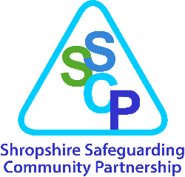

Shropshire Child Exploitation Risk Assessment Tool

(The information given throughout this form must be typed).

Before and during completion of this Child Exploitation Risk Assessment Tool please refer to:
- Shropshire Child Exploitation Initial Assessment Tool Practice Guidance
- Appropriate Language – Childrens Society Guidance for Professionals

Child’s forename | Child’s surname
DOB | Address
Ethnicity | Gender
Disability | Type of plan in place (EH, CIN, CP, LAC)
School/College | NHS/LCS Number
Is the child a looked after child? | Who is the responsible Local Authority and where is the child placed?
Name of professional completing Child Exploitation Risk Assessment | Agency
Contact details of person completing assessment including telephone number and email address | Date Child Exploitation Risk Assessment completed
Has the child given consent to the completion of this Risk assessment and sharing of information? | YES/NO if no please state why
Has the child contributed to the completion of this assessment?
Please record any views/comments of the child
Have both parents given consent to the completion of this assessment and sharing of information? | YES/NO if no please state why
Please record any views of both parents
If assessment is being completed/information is being shared without the consent of child/parents, state the reason why
Please list any agencies that contributed to the completion of this Risk Assessment Tool
Reason for completing this risk assessment (why now?)
Information needs to include whether there was an isolated incident/issue of concern which triggered the assessment, whether it was a recommendation from exploitation triage, or whether it is a combination of factors, or accumulation of concerns, etc

Child Exploitation Risk Assessment
The diagram below provides a framework to explore the needs of a child or young person who may be at risk of or being exploited. Information from the child, their parents/carer and partner agencies should be used to inform this risk assessment. Please refer to the Child Exploitation Practice Guidance to assist you in its completion.

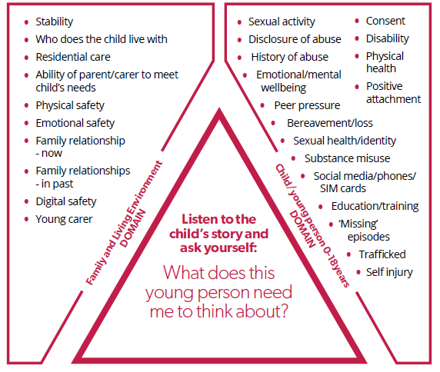
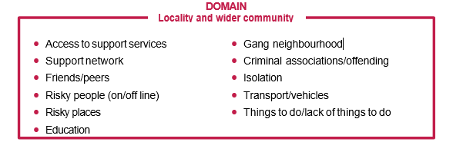

Child/Young Person Domain (link to the above)
What factors about this child identify that they may be at risk of exploitation or are being exploited?

Family and Living Environment Domain (link to the above)
What factors about the child’s family and living environment identify that they may be at risk of exploitation or are being exploited?

Locality and Wider Community Domain (link to the above)
What factors about the child’s locality and wider community identify that they may be at risk of exploitation or are being exploited?

Protective Factors
What strengths and protective factors can you identify that exist and can be used to meet this child’s needs?

Have you identified potential risks to other children or adults?
If answered yes and there is a risk to other children refer to the Shropshire Exploitation Pathway
If answered yes and there is a risk to adults:
- If an adult with care and support needs refer to the Adults Safeguarding Process in Shropshire.
- Any other adult: refer to Keeping Adults Safe in Shropshire Working with Risk Guidance
Have you identified perpetrators and/or locations that the child/young person frequents?
If answered yes please report child exploitation intelligence to West Mercia Police

Risk Assessment/determination
Based on the factors you have identified, please indicate your professional judgement as to the level of risk you believe this child faces:
Indicators the child/young person is vulnerable to child exploitation
Indicators the child/young person is being groomed or targeted for the purposes of child exploitation
Indicators the child is being exploited
Please indicate the type of exploitation (this could be more than one category)
criminal exploitation
sexual exploitation
forced marriage
modern slavery (including trafficking)
radicalisation
financial exploitation
other exploitation to secure benefits or services (specify)
Exploitation Triage is held twice weekly and consists of a range of practitioners, this risk assessment will be discussed and triage will determine the final risk level based on all available information and will update you about this and any actions/recommendations made.
Rationale:
Please provide a rationale as to why in your professional opinion you have determined the young person to be vulnerable/groomed or targeted/being exploited (delete as appropriate):

Accessing Support
In order to ensure a child/young person is accessing the right support at the right time, and to avoid repetitive processes for practitioners, it has been agreed with services that this risk assessment will be accepted as a referral to Branch Project; Climb and/or Compass for a Social Work Assessment (s.17), with parental consent therefore please indicate the parent has consented by ticking the relevant box below:
Branch
Climb
Children Social Care for s.17 Social Work Assessment (SWA)

Action following assessment
Child Exploitation Triage will review and determine the final risk level.
- Discuss and agree with the child and parent:
  - the completed assessment and gain consent to share it.
  - any interventions and support for the child or parents/carers
- Send the Child Exploitation Risk Assessment to Compass by secure email (compass.referrals@shropshire.gov.uk). It will be forwarded to the Child Exploitation and Missing Coordinator in Compass and allocated for discussion at Child Exploitation Triage.
- Where parental consent has not been sought or agreed to and there is not clear evidence that the child is being exploited or is at risk of significant harm, the risk assessment cannot be discussed at Child Exploitation Triage.

- Reporting a Crime: If you have documented a crime that has taken place within the CE Risk Assessment, please ensure this matter is reported via 101 or online reporting www.westmercia.police.uk and provide the police reference number here:

