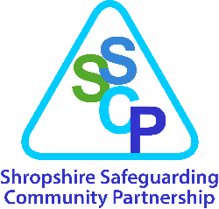

Shropshire Child Exploitation Intelligence Reporting

(sharing information to prevent and detect crime)

The ways in which children are exploited can amount to criminal behaviour by those who are exploiting them and/or as a presenting behaviour of a child who is being exploited.
There may also be behaviour that you witness in communities that cause you to be concerned that unknown children are being exploited (such as activity around addresses or locations).
If you have information about anti-social or criminal activity or behaviour (even where you do not know who is at risk or of concern) which indicates that child exploitation may be occurring and you do not have information about specific children, please ensure you pass this information to West Mercia Police as soon as possible to enable them to prevent and detect crime (s115 Crime and Disorder Act 1998). You can submit this information in the following ways:
- Report under the “Tell Us About” section on the West Mercia Police website or phone 101.
- Email the information directly to the West Mercia Police Child Exploitation Team in Shropshire: CETeamShropshire@westmercia.police.uk.
- Anonymously to Crimestoppers online or by calling 0800 555111.
- Where you think there is an immediate risk to a person or you witness a crime taking place, phone 999 (or dial 55 if you are unable to talk).
Note: Where you have child specific information which suggests that a child is at risk of or experiencing harm as a result of exploitation, you must follow the Child Exploitation Pathway and pass information related to criminal activity or behaviour posing a risk to West Mercia Police.
Children, their families and/or other members of the community may be worried about sharing information about crime with the police, but you can encourage them to do so anonymously by signposting them to:
- Crimestoppers
- Fearless (for young people)

