Shropshire Multi-Agency Referral Form
(MARF)

This form should be used to make contact with Children’s Social Care, should your request for a referral not be accepted then your information will remain as a contact on the child’s electronic record. PLEASE NOTE the parent will be notified of your contact and the actions taken, you will be copied into this letter as notification/feedback on your contact into Children’s Social Care.

BEFORE PROCEEDING PLEASE ensure you have referred to the Threshold Document on the local pages of the West Midlands Safeguarding Procedures.

You MUST inform those with parental responsibility of your contact and seek consent for a referral to be made.
Consent is not required for child protection referrals where it is suspected that a child may be suffering or be at risk of suffering significant harm; however, it is considered good practice to inform an adult with parental responsibility that you are making a referral, unless to do so may:
- Place the child at increased risk of Significant Harm
- Place any other person at risk of injury
- Obstruct or interfere with any potential Police investigation
- Lead to unjustified delay in making enquiries about allegations of significant harm
The child’s interest must be the overriding consideration in making such decision. Decisions should be recorded within your own agency’s records.

If the matter is urgent then please telephone First Point of Contact (FPOC) on 0345 6789021 or if you are concerned about an immediate risk telephone the police on 999. Following a verbal request for a referral the MARF must be fully completed and forwarded within 24 hrs to the Compass Team email account (you will need to do this securely*): Compass.Referrals@shropshire.gov.uk

First Point of Contact (FPOC) | 0345 678 9021
Out of hours Emergency Duty Team | 0345 678 9040

Have you obtained parental consent to make a referral and share information?
Yes No

If you haven’t obtained parental consent, why not?

- Child / Young Person Details (if more than one child can you please list all the children’s details in the boxes below, a separate MARF for each child is not required).
Child’s First Name |  |  |  |  |  |  |  | Child’s Surname / Last Name
Any alternative name

Date of Birth or Estimated Date of Delivery |  |  |  | Gender  (M/F) |  |  |  | Gender Identity |  | Language or preferred method of communication e.g. sign language
Religion |  |  |  | NHS number
Name of Parents / Carers: Include all adults involved in the care of the child |  |  |  |  | Date of Birth |  |  |  | Contact Telephone Number
Who holds parental responsibility? |  |  |  |  |  |  | Does the child have any special needs disability?
 |  |  |  |  |  |  | Yes No
Home Address: |  |  |  |  |  | Any other relevant addresses:
Post Code |  |  |  |  |  | Post Code
- Ethnic Origin (please check as applicable)
White: |  |  | ☐White English / Welsh / Scottish / Northern Irish / British  ☐White Irish ☐Gypsy or Irish Traveller  ☐Any other White background please specify………………
Mixed / Multi-Ethnic Group: |  |  | ☐White and Black Caribbean ☐White and Black African  ☐White and Asian ☐Any other Mixed Multi-Ethnic background, please specify……
Asian / Asian British: |  |  | ☐Indian ☐Pakistani  ☐Bangladeshi ☐Chinese  ☐Any other Asian background, please specify……………..
Black / African / Caribbean / Black British: |  |  | ☐African ☐Caribbean  ☐Any other Black / African / Caribbean background, please specify…
Other ethnic group: |  |  | ☐Arab ☐Any other ethnic group, please specify…………………
- Other Significant Family Members / Adults and children e.g. siblings, grandparents and any other people residing in the home
Name |  | Relationship |  |  |  | Contact Phone Number |  |  |  |  | Address
- Contact information: of other agencies involved if known (please add others you think may be relevant)
Agency |  |  | Name |  |  | Address |  |  |  |  | Telephone
GP

Health Visitor

School

School Nurse

Other Agency

Other Agency

Other Agency

Other Agency

- Have you discussed Early Help with the family prior to making this request for a referral? This is not designed to be a barrier but may offer the family the opportunity to engage in the support needed to address your concerns about the child(ren).
Yes  If yes please give details of the early help offered. |  |  |  |  |  |  | No  If Early Help wasn’t discussed or offered why not?
- Reason for request for referral
What evidence / information are your concerns based on, please identify your specific concerns. State how long you have known the child and in what capacity, i.e. as teacher, doctor etc Please give as much concise and evidence-based information as possible to help us in our assessment.
- What are your concerns for the child?
- Which level threshold level do you feel this referral meets
Level 1 Universal  Children with no additional needs and where there are no concerns. Typically, these children are likely to live in a resilient and protective environment where their needs are met. These children will require no additional support beyond that which is universally available. |  |  | Level 2  Early Help  These children can be defined as needing some additional support without which they would be at risk of not meeting their full potential. Their identified needs may relate to their health, educational, or social development, and are likely to be short term needs. If ignored these issues may develop into more worrying concerns for the child or young person. These children will be living in greater adversity than most other children or have a greater degree of vulnerability than most if their needs are not clear, not known or not being met a lead professional will coordinate a whole family assessment and plan around the child. |  |  | Level 3 –  Targeted Early Help  This level applies to those children identified as requiring targeted support. It is likely that for these children their needs and care are compromised. Only a small fraction of children will fall within this band. These children will be those who are vulnerable or experiencing the greatest level of adversity.  Children with additional needs: These children are potentially at risk of developing acute/ complex needs if they do not receive early targeted intervention. |  |  |  |  | Level 4 –Complex Significant Needs  These are children whose needs and care at the present time are likely to be significantly compromised thereby requiring assessment under Section 47 or Section 17 of the Children Act 1989. These children may become subject to a child protection plan and need to be accommodated (taken into care) by Children’s Social Care either on a voluntary basis or by way of Court Order. Section 17-1989 Children Act states a child shall be taken to be in need if: (a) He is unlikely to achieve or maintain, or to have the opportunity of achieving or maintaining, a reasonable standard of health or development without the provision for him of services by a local authority under this Part; (b) His health or development is likely to be significantly impaired, or further impaired, without the provision for him of such services; or (c) He is disabled.
- What support do you think this child/family require? For example, help managing the child(ren)’s behaviour, help managing the home conditions, respite, etc
- Is there a perceived risk that could place those making contact with this family in danger i.e violence to staff, dangerous dog, etc?
Yes No

If yes, please specify what the identifies risk is:

If you are making a request for a Child in Need referral, agreement must be sought from the parent/carer (and where appropriate the young person). If parental agreement is not obtained it will not be possible to progress a Child in Need referral.
If you are making a referral of a child protection concern and are unsure about whether to advise the parent/carer about the referral, you should consult your agency about this issue. If you remain unsure about whether the parent/carer should be contacted/informed about the referral i.e. due to evidence being compromised, or someone being placed at risk, please consult Children’s Services in the first instance.

- Referrer details
Name and Status

Email Address

Work Address

Contact Telephone Number
Signature

Date

The MARF must be fully completed and forwarded within 24 hrs of a telephone referral to the Compass Team Compass.Referrals@shropshire.gov.uk
Or

By post:

Compass
Mount Mckinley
Shrewsbury Business Park
Anchorage Avenue
Shrewsbury
SY2 6LG

* Government organisations have been advised to adhere to the TLS encryption delivery of email over the internet. Shropshire Council and Compass team will soon be sending out all secure data using TLS encryption.

Do you send and receive TLS 1.2 encrypted email? Please contact your support desk if you need advice or support.

Notification of the outcome of your request for a referral:
Shropshire’s procedures note The Children and Young People’s Services should acknowledge receipt of a written referral within ONE working day. If the referrer has not received an acknowledgement within THREE working days they should make contact with the relevant manager in the Children and Young People’s Services Team.
Please note as from 02.01.19 our process of notification is changing, as from 02.01.19 the parent will be notified of your contact and the actions taken, you will be copied into this letter as notification/feedback on your contact.

Appendix 1

BODYMAP
(This must be completed at time of observation)

Name of Child: |  |  | Date of Birth:
Name of observer: |  |  | Job title:
Date and time of observation:

Appendix 2  Name of child: |  |  | Date and time of observation:
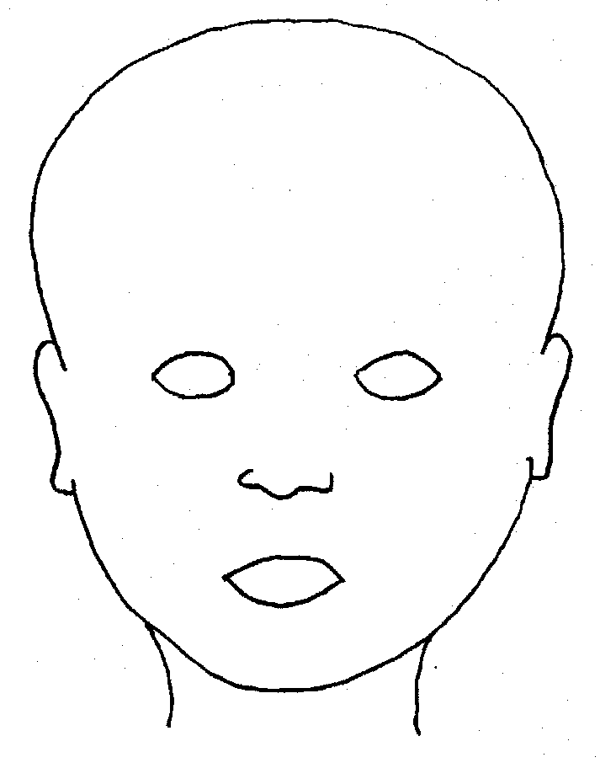
FRONT |  | BACK
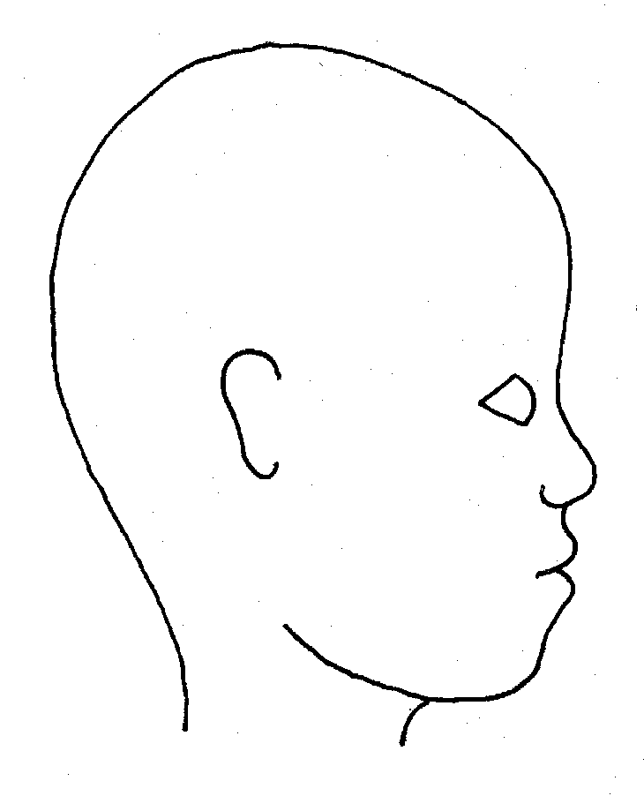 |  | 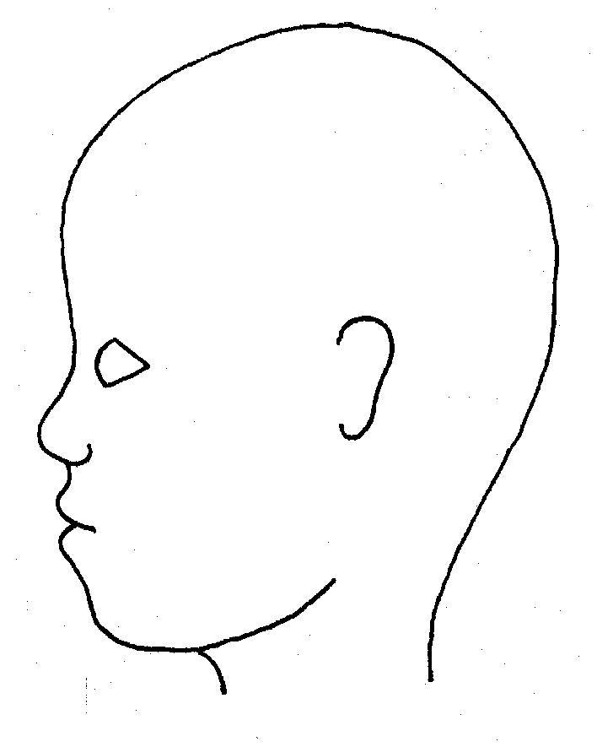
RIGHT |  | LEFT

Appendix 3  Name of child: |  |  |  |  |  | Date and time of observation:
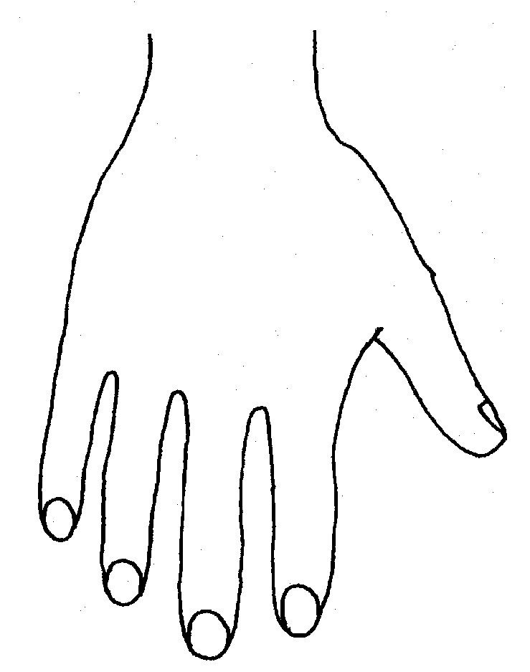 |  |  |  |  | 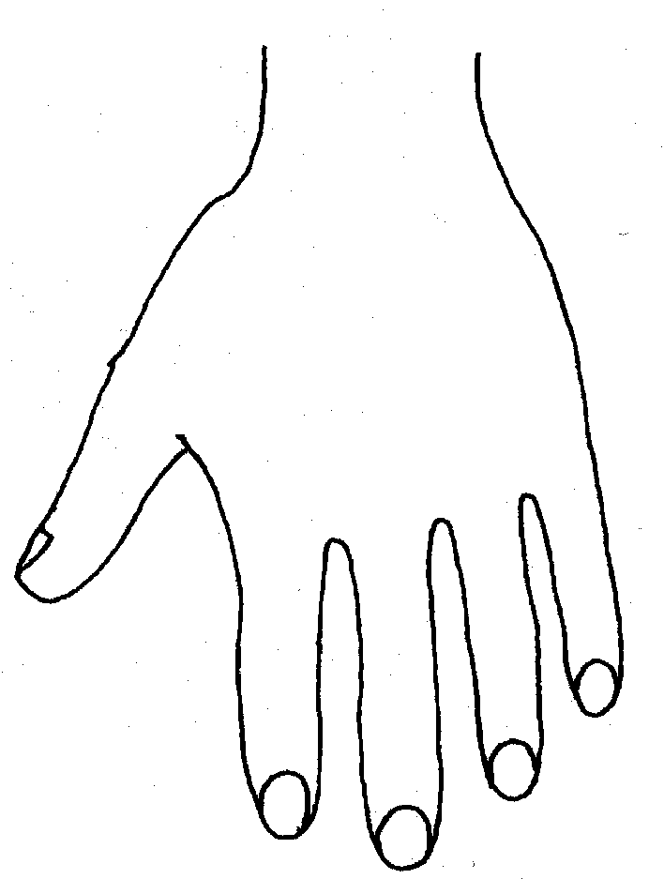
R |  |  |  |  | L
BACK
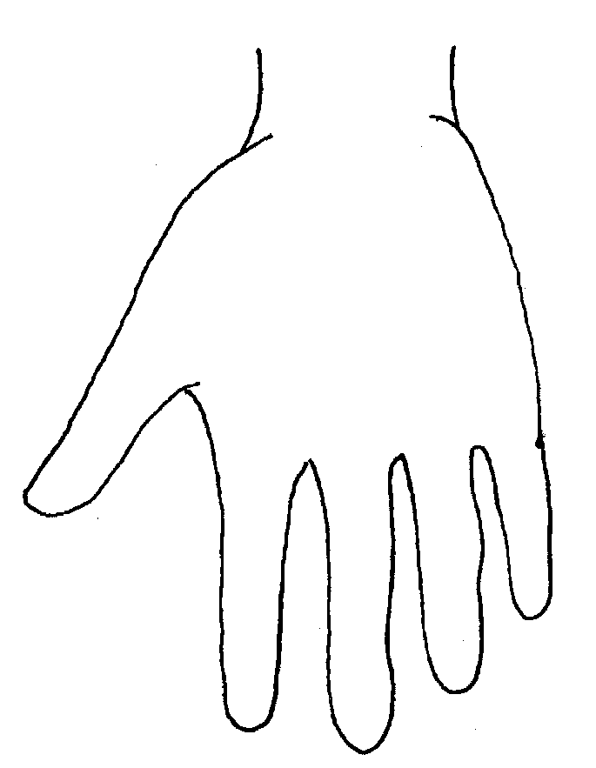 |  |  |  |  | 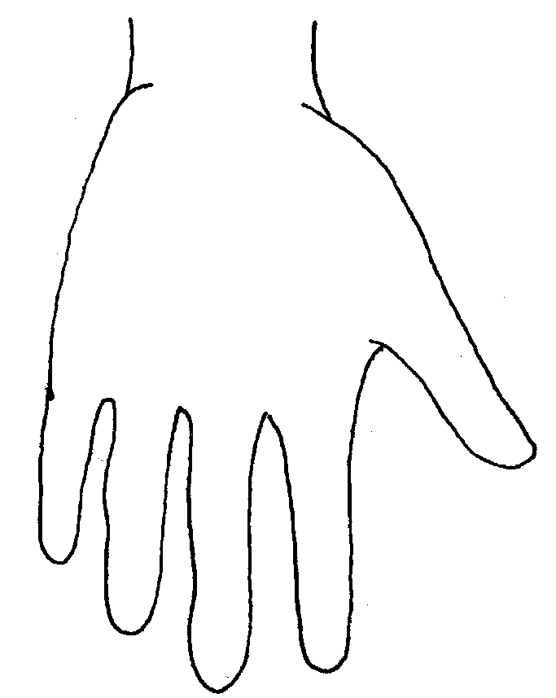
Appendix 4  Name of Child: |  |  |  |  |  | Date and time of observation:
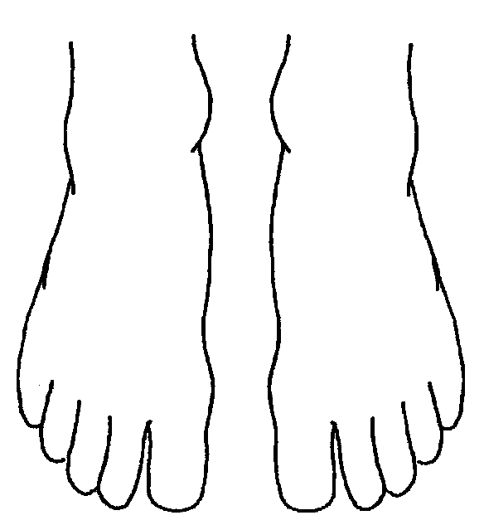 |  |  |  | 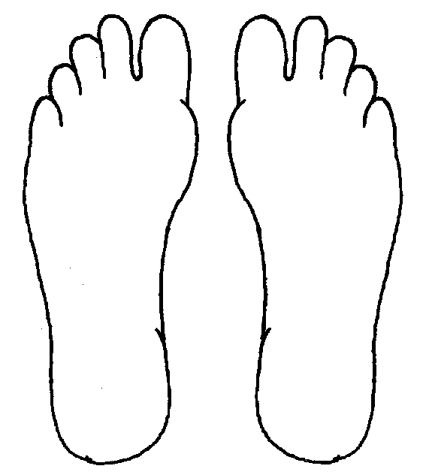
R | TOP |  | L | R |  |  | BOTTOM |  | L
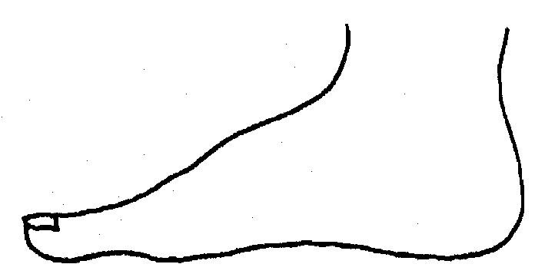
R |  |  |  | L
INNER
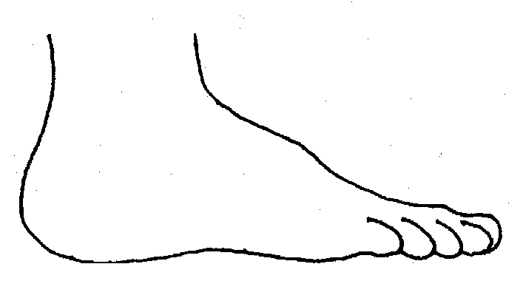 |  |  |  | 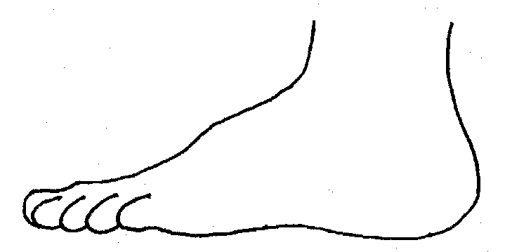
R |  |  |  | L
OUTER

