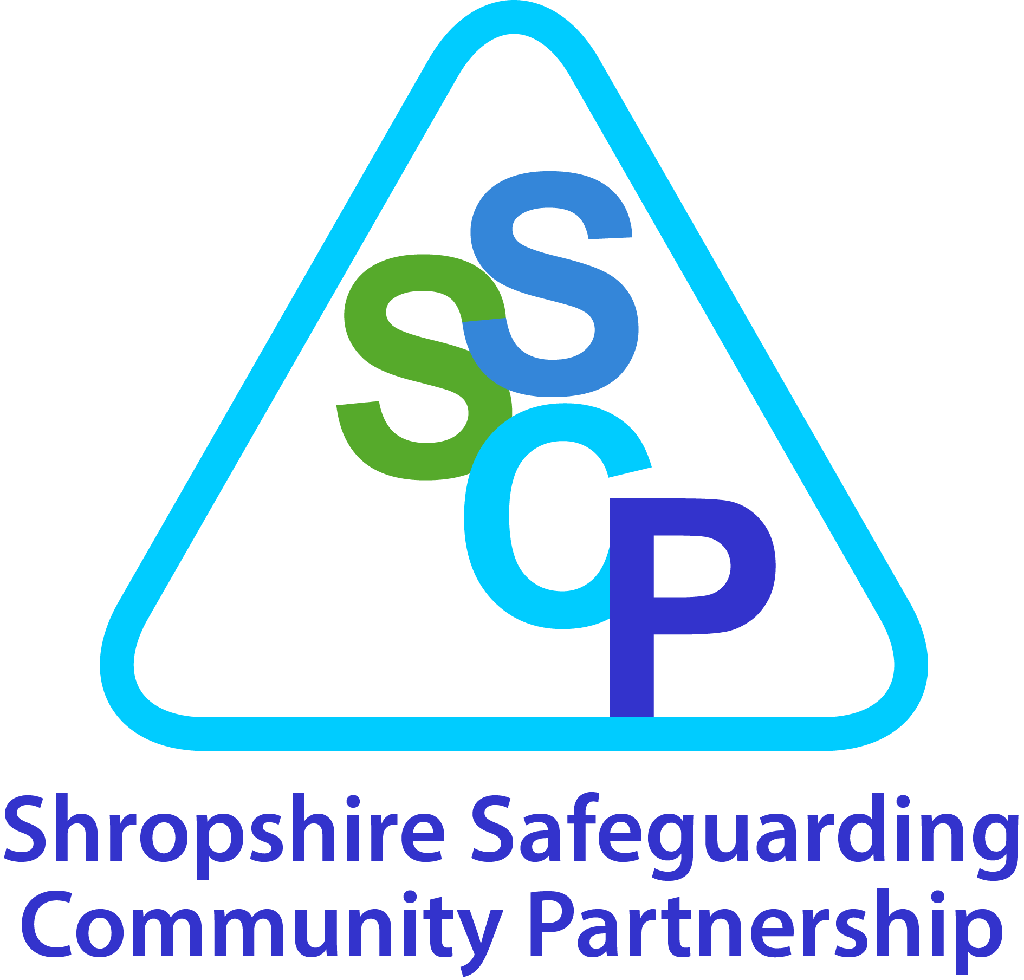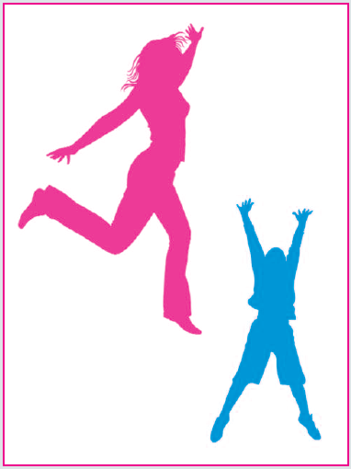

Self-Harm Pathway

Information, Advice and Guidance for Practitioners

Policy

Contents Page
1.0 What is self-harm 3
2.0 Self harming behaviour 4
3.0 What causes self harm 5
4.0 Warning signs 6
5.0 What keeps the cycle of self-harm going 7
6.0 How to respond 8
6.1 Immediate responses to self-harm 8
6.2 Required responses 8
6.3 Confidentiality 9

7.0 How to help 11
7.1 Conversations with young people 11

8.0 Strategies to help 12
8.1 Alternative Coping Strategies 12
8.2 Further considerations 13
8.3 Issues of contagion 14

9.0 Reporting- Initial Discussion Record 16

10.0 Support available 17
10.1 My safety net 17
10.2 Local sources of information 18
10.3 National Advice and Helplines 19
10.4 References and reading list 20
10.5 Care pathway 21

12.0 Risk Assessment toolkit and care pathway 22-26

This policy links to:

Shropshire Safeguarding Suicide Prevention Pathway and toolkit
Shropshire Safeguarding threshold document
Shropshire Safeguarding schools e-safety policy guidance
SSCB Child Sexual Exploitation Guidance & Pathway

SSCB website

1.0 What is self-harm?

Self -harm is a wide definition that includes eating disorders, self-injury, risk-taking behaviour and drug / alcohol misuse. This policy focuses on the self-injury aspect of self-harm.

Self-harm is a coping mechanism. An individual harms their physical self to deal with emotional pain, or to break feelings of numbness by arousing sensation.
Self-harm is any deliberate, non-suicidal behaviour that inflicts physical harm on the body and is aimed at relieving emotional distress. Physical pain is often easier to deal with than emotional pain, because it causes 'real' feelings. Injuries can prove to an individual that their emotional pain is real and valid. Self-harming behaviour may calm or awaken a person. Yet self-harm only provides temporary relief, it does not deal with the underlying issues. Self-harm can become a natural response to the stresses of day-to-day life and can escalate in frequency and severity.

Self -harm can include but is not limited to, cutting, burning, banging, bruising and scratching.
Self-harm is often habitual, chronic and repetitive; it tends to affect people for months and sometimes years.

People who self-harm usually make a great effort to hide their injuries and scars, and are often uncomfortable about discussing their emotional inner or physical outer pain. It can be difficult for young people to seek help from the NHS or from those in positions of authority, perhaps due to the stigma associated with seeking help for mental health issues. Self injury is usually private and personal, and it is often hidden from family and friends. People who do show their scars may do so as a reaction to the incredible secrecy of their emotions and feelings which they are unable to share, and one should not assume that they are attention seeking, although attention may well be needed.

Over the past 40 years, there has been a large increase in the number of young people who deliberately harm themselves. The Mental Health Foundation/Camelot Foundation (2006) suggests there are “probably 2 young people in every secondary school classroom who have self-harmed at some time” (The truth about self-harm. London: MHF/CF)

One in twelve children and young people are said to self-harm, and over the last ten years inpatient admissions for young people who have self harmed have increased by 68%. Among females under 25, there has been a 77% increase in the last ten years (SCIE, 2005; NICE)

Four times as many girls as boys self harm up to the age of 16, although this ratio reduces to twice as many among 18-19 years olds (SCIE, 2005; HSCIC, 2013)

Self-harm usually begins between 13 and 18 years of age and while frequently mild and transient, can, in some cases persist for up to 10 years (McAllister et al, 2010). Lifetime rates are reported of up to 33% among secondary school students self- harming, with approximately 10% of those engaging in relatively severe self-harm (McAllister et al, 2010)

Self-harm is not confined to children of secondary school age. Though it may manifest in different forms of behaviour, children at Primary Schools may also self-harm.

Accurate assessment, early detection and early intervention are essential to the successful treatment of self harm (Sharpio, 2008)
12 Dec 2014
Deliberate self-harm was one of the top 5 reasons for referral into T3 CAMHS in Shropshire during 2013/2014. Of the 90 referrals to T3 71 were female. Referrals for self-harming behavior were also reflected in the top 10 reasons. (Source: CAMHS Graphnet, 2013-14).
2.0 Self harming behaviours?

Factors that motivate people to self-harm include a desire to escape an unbearable situation or intolerable emotional pain, to reduce tension, to express hostility, to induce guilt or to increase caring from others.

Even if the intent to die is not high, self harming may express a powerful sense of despair and needs to be taken seriously. Moreover, some people who do not intend to kill themselves may do so because they do not realise the seriousness of the method they have chosen or because they do not get help in time.

Examples of Self-harming behaviour
- Cutting
- Taking an overdose of tablets
- Swallowing hazardous materials or substances
- Burning, either physically or chemically
- Over/under medicating, e.g. misuse of insulin
- Punching/hitting/bruising
- Hair-pulling/skin-picking/head-banging
- Episodes of alcohol/drug abuse or over/ under eating at times may be deliberate acts of self-harm.
- Risky sexual behaviour
- Inserting objects into the skin

3.0 What causes self-harm?
The following risk factors, particularly in combination, may make a young person vulnerable
to self-harm, although are not limited to:
Individual factors:
- Depression/anxiety
- Poor communication skills
- Low self-esteem
- Poor problem-solving skills
- Hopelessness
- Impulsivity
- Substance misuse
- Bereavement
- Perfectionism
- Exam pressure
Family factors
- Unreasonable expectations
- Neglect or abuse (physical, sexual or emotional)
- Child being Looked After
- Poor parental relationships and arguments
- Parental separation and / or loss
- Depression, deliberate self-harm or suicide in the family.
Social Factors:
- Difficulty in making relationships/loneliness
- Persistent bullying or peer rejection
- Easy access to drugs, medication or other methods of self-harm.
- Copied self-harm behaviour (contagion effect)
- Difficult times of year e.g. anniversaries
- Criminal behaviour
- Accessing or difficulties within school

4.0 Warning signs

There may be a change in the behaviour of the young person that is associated with self-harm or other serious emotional difficulties, these may not be visible. Signs to be aware of may include:
- Changes in eating/sleeping habits
- Increased isolation from friends/family
- Changes in activity and mood, e.g. more aggressive than usual or more withdrawn
- Lowering of academic grades
- Talking about self-harming or suicide
- Frequent injuries (i.e., cuts, bruises, burns) with suspicious explanations.
- Wearing trousers and long sleeves in warm weather (to cover injuries).
- Wearing bangles, bracelets and wristbands (to cover injuries).
- Low self-esteem or an increase in negative self-talk.
- Difficulty handling emotions or easily overwhelmed.
- Extremely sensitive to rejection.
- Self-defeating comments and attitude.
- Extreme emotional ups and downs (due to the cycle of self-injury).
- Difficulty functioning at school, work or home.
- Relationship problems.
- Avoiding sports or other activities that would require showing more of one’s body.
- The presence of behaviours that often accompany self-injury: eating disorders, drugs/alcohol misuse, excessive risk-taking.
- Discovery of tools used for self-injury (broken disposable razors, lighters, un-bent paper clips).
- Bloodied wads of tissue or toilet paper, blood on clothing.
- First aid supplies being used quickly.
- Rubbing of arms, especially wrist, through sleeves (cuts often itch while they are healing).
- Withdrawing from activities once enjoyed.
- Increased time alone.
- Increased time with peers who self-injure.

5.0 What keeps the self-harm cycle going?

Once self-harm, particularly cutting, is established, it may be difficult to stop. Self-harm can have a number of functions for the student and it becomes a way of coping, for example:
• Reduction in tension (safety valve)
• Distraction from problems
• Form of escape
• Outlet for anger and rage
• Opportunity to feel real
• Way of punishing self
• Way of taking control
• To not feel numb
• To relieve emotional pain through physical pain
• Care-eliciting behaviour
• Means of getting identity with a peer group
• Non-verbal communication (e.g. of abusive situation)
- Suicidal act.

When a person inflicts pain upon him or herself, the body responds by producing endorphins, a natural pain-reliever that gives temporary relief or a feeling of peace. The addictive nature of this feeling can make the stopping of self-harm difficult.

Young people who self-harm still feel pain, but some say the physical pain is easier to stand than the emotional/mental pain that led to the self-harm initially.

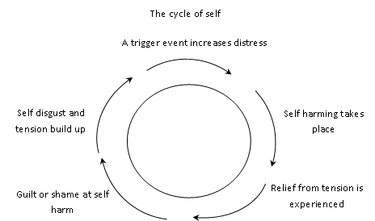
Understanding the Cycle of Self Harm Life Centre

- How to respond

6.1 Immediate response to self-harm

When a young person presents themselves with concerns about self-harm or when we are asked to look into a concern about a child our immediate response needs to be calm and measured. The professional should indicate they feel confident they can be supportive (no matter how anxious they may feel) as his will gain not only the child/young person’s confidence

Initially acknowledge the courage it has taken for the child/young person to seek help and acknowledge the self-harm. At this point it is important to communicate your acceptance of the situation and let them know you care but also to let them know the limits of your confidentiality, explain the reason why the information needs to be shared in order to keep them safe.

6.2 Required responses
If you find a young person who has self-harmed, try to keep calm, give reassurance and follow the first-aid guidelines. In the case of an over-dose of tablets, however small, advice must be obtained from a medical practitioner (accident and emergency department or GP).
When considering what action and support the young person needs, continue to maintain their trust and involve them in decisions.
Follow the policy of informing the designated person for child protection within your agency.
Parents will be contacted by the worker to whom the disclosure is made or in consultation with the designated lead.
Discuss your concerns with the young person’s parents, unless to do so would place the young person at further risk (see Child Protection Procedures and/or school safeguarding policies and procedures). If parents/carers are not contacted the reason must be documented and consultation with an Early Help Advisor is available.
Help the carers/parents to understand the self-harm so they can be supportive of the young person. Information for parents is available on pages 22 and 23 of these Guidelines.
Working with a young person who is self-harming can be distressing. Seek support from colleagues and the designated person for child protection in your agency.
You may wish to complete the self-harm initial discussion record on (page 14). Depending on the nature and severity of the self-harm you will need to choose appropriate and proportionate responses from the list below: (also see care pathway on page 19)
- Continue to monitor the self-harm and discuss with someone who will be able to build a relationship with the young person and provide advice, for example through school pastoral systems.
- Provide the young person with information and advice sheet (page 20 and 21) continue to consider whether further assessment and support may be needed.
- If you are concerned about a young person who is deliberately self harming complete the assessment at back of toolkit and include a webstar score, including the risk assessment to provide full details of needs and concerns.
- Consult with your school nurse, the child’s GP or with a Primary Mental Health Practitioner. In addition to the risk assessment.
- If you require targeted early help complete the Early Help Targeted Referral Form. https://shropshire.gov.uk/early-help/practitioners/early-help-forms/
- Discuss with the young person, their parents, year head and any other agencies your plans. Identify strengths, skills and risk factors and make a plan to address any vulnerability. If you cannot identify the necessary agency send the referral and assessment to COMPASS.
- Following assessment please refer to the pathway
- Low risk – do not submit assessment provide support through universal services
- If it meets the criteria on page 31 submit assessment to seek consultation with ACCESS BEE U – 0300 124 0093
- If you identify child protection concerns, follow school/ agencies procedures around how to make a referral. Document any reported concerns and record who you spoke to, the time, date and any advice they have given you to follow.

6.3 Confidentiality

Confidentiality is a key concern for young people, and they need to know that it may not be possible for you to offer this. If you consider that a young person is at serious risk of harming him or herself or others, then information needs to be shared. It is important not to make promises of confidentiality that you cannot keep, even though the young person may put pressure on you to do so.

If this is explained at the outset of any meeting, then the young person can make an informed decision as to how much information he or she wishes to divulge.

Make sure that as part of your conversation you work out together who are the best people to tell. Discuss with the young person the importance of letting his or her parents know, unless telling them would put the young person at higher risk or increase anxiety and their distress. Discuss any fears he or she may have about this. Work through together what words you will use to explain to parents/ carers so that there are no surprises.
7.0 How to help
- Arrange a mutually convenient time and place to meet
- At the start of the meeting, set a time limit.
- Make sure the young person understands the limits of your confidentiality.

7.1 Conversations with the young person
- When you recognise signs of distress, try to find ways of talking with the young person about how he or she is feeling.
- What is important for many young people is having someone to talk to who listens properly and does not judge.
- Resist the temptation to tell them not to do it again, or make a promise you that they won’t do it again
- Take a non-judgemental attitude towards the young person. Try to reassure the person that you understand that the self-harm is helping him or her to cope at the moment and you want to help.

It is important that all attempts of suicide or deliberate self-harm are taken seriously and that the young person listened to carefully. All mention of suicidal thoughts should be noted and reported appropriately following the schools or agencies safeguarding policy and procedures.

Understanding the individual’s experience
The only way to understand a child/young persons’ experience is talk to them about what is happening for them. Below are some questions/ideas that may be useful in developing that conversation

Simple things you can say:
- ‘I’ve noticed that you seem bothered/worried/preoccupied/troubled. Is there a problem?’
- ‘I’ve noticed that you have been hurting yourself and I am concerned that you are troubled by something at present’
- ‘We know that when young people are bothered/troubled by things, they cope in different ways and self injury is one of these ways. Is this something you have tried or thought about?
- ‘Young people who do self-harm may need support from someone who understands problems in relation to self injury. Unfortunately I don’t have the skills to help, but I would like to help by asking (Name of counsellor/ pastoral support/ agency) to see you. Would you agree to this?’
Questions you may find helpful to add more detail to your assessment of need:
- What was happening when you first began to feel like injuring yourself?
- What seems to be the trigger feeling now?
- Are you always at a certain place or with a particular person?
- Do you have any frightening memories or thoughts?
- Is there anything else that makes you want to hurt yourself?
- What did you do? What form of self-harm is being used?
- Was it planned or impulsive?
- Were drugs or alcohol involved?
- Where and how did you learn to self-harm?
- Do you know anyone else who self-harms?
- Does anyone know you self-harm? What have they said/ done?
- When you manage to cope without self-harming what alternatives find work for you?
If they indicate the thought they wish to die or any expressions of suicidal ideation are shared please refer to the suicidal toolkit and care pathway.

8.0 Strategies to help

8.1 Coping strategies

Replacing the cutting or other self harm with other safer activities can be a positive way of coping with the tension. What works depends on the reasons behind the self-harm. Activities that involve the emotions intensively can be helpful. Examples of alternative ways of coping include:
- Using a creative outlet e.g. writing poetry &songs, drawing and talking about feelings
- Writing a letter expressing feelings, this need not be sent
- Contacting a friend or family member
- Ringing a helpline
- Access to appropriate websites listed on page 18/19
- Going into a field and screaming
- Hitting a pillow or soft object
- Listening to loud music or singing
- Going for a walk/run or other forms of physical exercise - Research tells us that increasing adrenaline and heart rate through strenuous physical activity, can in some cases provide a more similar response to the act of self harming, and therefore be a more effective replacement coping strategy than relaxation type activities for some young people
- Getting out of the house and going to a public place, e.g. a cinema
- Reading a book
- Keeping a diary
- Using stress-management techniques, such as relaxation
- Having a bath
- Looking after an animal
For some young people, self-harm expresses the strong desire to escape from conflict or unhappiness

In the longer term, the young person may need to develop ways of understanding and dealing with the underlying emotions and beliefs family support is likely to be an important part of this.

It may also help if the young person joins a group activity such as a youth club, a keep-fit class or a school-based club that will provide opportunities for the person to develop friendships and feel better about him or herself. Learning problem solving and stress-management techniques, ways to keep safe and how to relax may also be useful. Increasing coping strategies and developing social skills will also assist. Regular counselling/therapy may be helpful so too may arts based therapeutic interventions which offer the young person the opportunity to explore their thoughts, feelings and needs in a safe and non-judgemental environment

Students may present with injuries to first-aid or reception staff. It is important that these frontline staff are aware that an injury may be self-inflicted and that they are aware of these guidelines and able to pass on any concerns.

- It may be helpful to explore with the young person what led to the self-harm – the feelings, thoughts and behaviours involved. This can help the young person make sense of the self-harm and develop alternative ways of coping.
- Encourage the young person to talk about what has led him or her to self-harm
- Remember that listening is a vital part of this process.
- Support the young person in beginning to take the steps necessary to keep him or her safe and to reduce the self-injury (if he or she wishes to) for example:
- If a young person lacks resilience, consider ways to help the young person build their self-esteem. Help the young person to find his or her own ways of managing the problem e.g. talking, writing, drawing or using safer alternatives, if the person dislikes him or herself, begin working on what he or she does like, if life at home is impossible, begin working on how to talk to parents/carers.
- Help the young person to identify his or her own support network
- Offer information about support agencies – see the leaflets pages 22-27. Remember that some internet sites may contain inappropriate information. For appropriate websites please see pages 18/19.

8.2 Further considerations
- Record any meetings with the young person. Include an agreed action plan, including dates, times and any concerns you have, and document who else has been informed of any information.
- It is important to encourage young people to let you know if one of their group is in trouble, upset or shows signs of harming. Friends can worry about betraying confidences, so they need to know that self-harm can be dangerous to life and that by seeking help and advice for a friend they are taking a responsible action.
- Be aware that the peer group of a young person who self-harms may value the opportunity to talk to an adult, individually. If you have a number of young people who self harm in your school, you may consider consulting your Primary Mental Health Worker and Educational Psychologist.
- It is important to engage parents/carers at an appropriate point as evidence shows that this can be a protective factor. Explain that evidence from research informs us that when parents/ carers can be engaged long term mental health outcomes are improved. Feedback from young people, also tells us, many of those who didn’t want to inform their parents, in the long term were pleased that they did stating that having support and understanding at home helped with long term recovery.
Harm Minimisation
Keeping wounds clean is essential; this may be the first step to recovery. This may be difficult but patience and care can be influential in promoting health and recovery and may be enough to help the young person feel back in control accepted and less isolated.
Ways to encourage this:
- Washing implements used to cut
- avoiding alcohol if it’s likely to lead to self-injury
- taking better care of injuries, keeping wounds clean to prevent infection
Response of supportive members of staff
For those who are supporting young people who self harm, it is important to be clear with each individual how often and for how long you are going to see them, i.e. the boundaries need to be clear. It can be easy to get caught up in providing too much help, because of one’s own anxiety. However, the young person needs to learn to take responsibility for his or her self-harm.
If you find that the self-harm upsets you, it may be helpful to be honest with the young person. However, be clear that you can deal with your own feelings and try to avoid the young person feeling blamed. The young person probably already feels low in mood and has a poor self-image; your anger or upset may add to his or her negative feelings. However, your feelings matter too. You will need the support of your colleagues and management if you are to listen effectively to young people’s difficulties.
Issues regarding contagion
When a young person is self-harming, it is important to be vigilant in case close contacts of the individual are also self-harming. Occasionally, schools discover that a number of students in the same peer group are harming themselves. Self-harm can become an acceptable way of dealing with stress within a peer group and may increase peer identity. This can cause considerable anxiety, both in school staff and in other young people
Each individual may have different reasons for self harming and should be given the opportunity for one-to-one support. In general, it is not advisable to offer regular group support for young people who self-harm. Be aware that young people may seek support through the internet where the advice they are offered may be counter-productive.
Support/training aspects for staff
Staff members giving support to young people who self-harm may experience all sorts of reactions to this behaviour in young people, such as anger, helplessness and rejection. Staff will need to have an opportunity to talk this through with work colleagues or senior management. It may also be useful to refer to MindEd training modules www.minded.org.uk for further information and guidance.
Staff members with this role may find it helpful to attend training, to access resources that may be available and liaise with other professionals – such as the CAMHS Primary Mental Health Workers or school nurses.
General aspects of prevention of self-harm
An important part of prevention of self-harm is having a supportive environment in the school that is focused on building self-esteem and encouraging healthy peer relationships. An effective anti-bullying policy and a means of identifying and supporting young people with emotional difficulties is an important aspect of this.

This form will help you structure and record a conversation about what Early Help support a child/young person or family might need and record your decision about what needs to happen next.
Child/young person’s name DOB

Who is completing the form with whom
(give detail of name and organisation where appropriate)

Date of record completion
What has prompted this discussion?

What part of this is worrying you?

How long has this been happening?

Has anything changed? (in the family’s situation)

Have there ever been similar problems in the past? (What worked? What didn’t work?)

What do you think might happen if things do not change?

What do you want to happen now?

Initial Discussion record v.1 2013
Initial Discussion Record

Professional use - What needs to happen now?

No further action – universal response | Continue to monitor | Other/internal processes | Contact FIS /signpost to other support | single agency targeted response  Complete assessment | Multi-agency targeted response  Complete assessment | Consult specialist service.  Complete assessment

- Support available

10.1 My safety net
There are different types of people in our lives. Try to identify some people in each of the groups below that you would feel most comfortable talking to:
• Family and close friends
• Friends and people you see every day
• Help lines and professional people you could go to for help.
Also, write into the space below the safety net the things that you can do yourself to cope with difficult feelings and keep yourself safe.

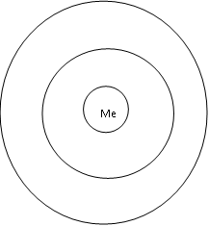

Things I can do myself to cope with difficult feelings

There are other ways to represent a safety net. e.g. using a hand

10.2 Local sources of information

BEEU ACCESS – 0-25 Mental Health Service
0300 124 0093 - beeu.org.uk
KOOTH
Free, anonymous online counselling through your phone, tablet, laptop or PC. Anyone aged 11-25, living in Shropshire and Telford & Wrekin, can register to access this service. No referral is needed - www.kooth.com
CHILDRENS SOCIETY
Drop-in service, BEAM, is now available from The Children’s Society (no referral required) - AskBeam@childrenssociety.org.uk
COMPASS via FPOC
0345 678 9021
MIND Info Line
0845 766 0163 / 01743 3686647

Professionals Line (SPOA) for the Public Health Nursing Service:
01743 730090
GP or NHS direct 111
111
Family Information Service
01743 25400
www.shrosphirefamilyinfo.co.uk

Shropshire Youth Association
http://www.sya.org.uk/

EnHance
01743 252740
vcsassembley@shropshire.gov.uk

Targeted Youth Support
0345 678 9008

Lifelines
01743 210940

Crown House
Substance Misuse Team
01743 258800

10.3 National Advice and Help Lines

Childline
24hrs helpline for children and young people under 18 providing confidential counselling
0800 1111 www.childline.org.uk

PAPYRUS
Offers a helpline to give support, practical advice and information to anyone who is concerned that a young person may be suicidal
HOPELineUK 0800 068 41 41
www.papyrus-uk.org

Bristol Crisis Service for Women (national support available)
Supports women and girls in emotional distress, especially those who self-harm, or their friends or relatives.
Provides publications and holds list of local groups throughout the country.
Limited opening hours tel: 0117 925 1119

National Self-Harm Network
Support for people who self-harm, provides free information pack to service users.
www.nshn.co.uk

Samaritans
Confidential emotional support for anybody who is in crisis. The Samaritans are piloting a project at KS3/4 in a number of schools which supports staff in working with young persons who self harm/experience suicidal thoughts - www.samaritans.org/youremotionalhealth/workinschools. The site includes other ideas and support strategies.
08457 90 90 90 www.samaritans.org.uk

Young Minds
Information on a range of subjects relevant to young people.
www.youngminds.org.uk

Minded
MindEd is a free educational resource on children and young people’s mental health for all adults
www.minded.org.uk

Young Minds Parents Information Service
0808 802 5544

The Site
There are many other projects out there traceable through phone directories, web searches etc.
www.thesite.org

NSPCC
www.nspcc.org.uk

If schools experience difficulty accessing any of these sites please contact LA IT to request firewalls be removed.
Please note that the authors cannot take responsibility for any advice obtained from third parties

10.4 References and reading list

Health and Social Care Information Centre (HSCIC) (2013) Hospital Statistics On
Teenagers. Available at:http://www.hscic.gov.uk/article/3579/Hospital-statistics-onteenagers-girls-predominate-in-self-harm-cases-boys-in-assaults (Accessed: 3 Oct, 2013)

McAllister, M., Hasking, P., Estefan, A., McClenaghan, K. and Lowe, J. (2010) A
Strengths-Based Group Program on Self-Harm: A Feasibility Study, School Nursing, 26
(4), pp. 289 – 300.

Meltzer, H., Lader, D., Corbin, T., Singleton, N., Jenkins, R. and Brugha, T. (2002) Non-
Fatal Suicidal Behaviour Among Adults aged 16 to 74 in Great Britain. London: The
Stationery Office.

National CAMHS Support Service (2011) Self-harm in Children and Young People
Handbook. Available at: http://www.chimat.org.uk/resource/item.aspx?RID=105602

National Institute for Health and Clinical Excellence (2013) Providing Help for Those Who
Self-Harm. Available at:
http://www.nice.org.uk/newsroom/features/ProvidingHelpForThoseWhoSelfHarm.jsp

Shapiro, S. (2008) Addressing Self-Injury in the School Setting, School Nursing, 24 (3)
pp. 124 – 130.

Social Care Institute For Excellence (SCIE) (2005) Research Briefing 16: Deliberate Self
Harm (DSH) Among Children and Adolescents. London: SCIE.

10.5
Care Pathway – self harming risk
Initial concerns
- Information from friends
- Disclosure of self harm
- Direct observation

Use the self-harm policy guidance and follow Care Pathway
Concerning response to Initial Discussion Record and policy guidance
- Complete Risk Assessment (with consent)
- Explain limits of confidentiality
- Discuss with colleagues: Designated Lead, school nurse, BEE U.
Medium or High Risk
- Send a copy of the Risk Assessment along with the webstar score to BEE U
- If asking for a targeted service complete a targeted referral form
- Inform support network
- Co-ordination of support plan. May include: School nurse, Primary Mental Health Practitioner, Targeted Youth Support, school support staff, counsellor, parent/ carers, voluntary sector agencies
- Contact BEE U on 0300 124 0093 for consultation/advice
(Tier 2 direct work needs to link to the threshold document)
Action Plan and support for:
Young Person
Information and Advice sheet given YES/ NO
Helplines and Website given
YES/ NO
Safety Net complete YES/ NO

Parent/Carer
Information and Advice sheet given YES/ NO
Helplines and Website given
YES/ NO

Professionals (have a named person who will be the point of contact)

Third Parties
(other young people)

No evidence of self harm thoughts or behaviour
- No Care Pathway actions
- Consider Early Help Assessment Framework if concerned that young person has additional needs
- Follow your internal safeguarding or EH procedures

Low risk
- No Care Pathway referral required
- Ensure ongoing support for young person, parent/carer and professionals at Tier 1
- Monitor, record and reassess if concerns persist, complete Early Help discussion record

Emergency Action
- If self harm actions cause significant injury (e.g. deep cutting or an overdose) call emergency services
- Contact Shropdoc if out of hours and copy assessments to them if agreed - 0333 222 6655
- If non-urgent but serious self-harm seek medical attention (e.g. school first aid or GP)

Consent
- Young people’s and parent/carers consent should be obtained for screening and assessment - discuss with BEE U
- Consent is overridden if the young person (or a third party) is at risk of significant harm

Copy referral to COMPASS/EDT if there is an associated safeguarding concern



Self-Harm

Risk Assessment

Self Harm Risk Assessment

Assessing the level of risk
Supporting guidance tools for assessing self-harm and risk management

Section 1 Protective factors and risk factors

This framework, is a guide for practitioners and managers in every school and agency that works with, or is involved with children, young people and their families. Its aim is to assist practitioners and managers in assessing and identifying a child’s level of need.

The aim is that as far as possible children’s needs should be met within universal provision, but that flexible support should be introduced to meet additional needs with the consent of the child and
parents, at the earliest possible stage, thus helping to achieve good outcomes and to prevent an increase in difficulties. Relevant factors should be included in the full assessment.
Protective Factors | Risk Factors
Family Factors | Family Factors
Child  • High self-esteem  • Good problem solving skills  • Easy temperament  • Able to love and feel loved  • Secure early attachments  • Good sense of humour  • A love of learning  • Being female  • Good communication skills  • Belief in something bigger than the self  • Having close friends | Child  • Low self-esteem  • Few problem solving skills  • Difficult temperament  • Unloving and reject love from others  • Difficult early attachment  • Tendency to see things literally  • Fear of failure  • Genetic vulnerability  • Being male  • Poor communication skills  • Self-centred thinking  • Rejected/isolated from peer group
Parents  • High self-esteem  • Warm relationship between adults  • High marital satisfaction  • Good communication skills  • Good sense of humour  • Capable of demonstrating unconditional love  • Set developmentally appropriate goals for the child  • Provide accurate feedback to the child  • Uses firm but loving boundaries  • Believes in and practice a ‘higher purpose’ | Parents  • Low self-esteem  • Violence or unresolved conflict between adults  • Low marital satisfaction  • High criticism/low warmth interactions  • Conditional love  • Excessively high or low goals set for the child  • Physical, emotional or sexual abuse  • Neglect of child’s basic needs  • Inconsistent or inaccurate feedback for the child  • Parents with drug or alcohol problems  • Parental mental health problems
Environmental Factors | Environmental Factors
School  • Caring ethos  • Students treated as individuals  • Warm relationships between staff and children  • Close relationships between parents and social  • Good PHSE  • Effectively written and implemented behaviour, anti-bullying, pastoral policies  • Accurate assessment of special needs, with appropriate provision | School  • Excessively low or high demands placed on child  • Student body treated as a single unit  • Distance maintained between staff and children  • Absent or conflictual relationships between staff and school  • Low emphasis on PHSE issue  • Unclear or inconsistent policies and practice for behaviour bullying and pastoral care  • Ignoring or rejecting special needs
Housing and community  • Permanent home base  • Adequate levels of food and basic needs  • Access to leisure and other social amenities  • Low fear of crime  • Low level of drug use in the community  • Strong links between members of the community | Housing and Community  • Homelessness  • Inadequate provision of basic needs  • Little or no access to leisure and other social amenities  • High fear of crime  • High levels of drug use  • Social isolated communities

Self Harm Risk Assessment

Self-harm risk factors

Section 2

Name | Male/ Female | Age
Name of person completing this form: | Organisation/service | Date Completed

At Risk ‘Groups’

Complete this with the young person and tick all boxes which apply to you:

- I am a Looked After Child

- I am excluded from school/college

- I have poor attendance

- I have a social worker

- I have a learning disability

- I have a developmental disorder e.g. ADHD, Asperger’s

- I am currently, or have in the past received support from CaMHS

- I have family members who have mental health problems

- I am a young carer

Section 2
At Risk ‘Situations’

Complete this with the young person and tick all boxes which apply to you:

- I am homeless- living in supported accommodation, temporary accommodation or sofa surfing

- I have had repeated injuries when under the influence of drugs or alcohol

- I have caused other to become concerned about my lifestyle

- I have regular, unplanned, unprotected sex

Self Harm Risk Assessment

Self-harm risk indicators

Section 3

Name | Male/ Female | Age
Name of person completing this form: | Organisation/service | Date Completed

Intrinsic - Self Harm - Risk Indicators
Risk indication | Protective Factors | Low Risk | Med Risk | High Risk
Eating | No issues | Missing meals, comfort eating | Weight changes evident | Severe weight loss, food refusal
Self-Poisoning | No issues | Threats to self-poison | Threats to self-poison; evidence of planning | Poison ingested
Alcohol/Drug use inc, solvents | No issues | Culturally appropriate use | Regular use | Uncontrolled use
Self-cutting | No issues | Scratching picking skin | Breaking skin, causing sores, superficial cuts | Needs Suture
Burning | No issues | Thinking about burning | Superficial burns | Deep burns
Sexual Activity | No issues | Not sexually active within peer group norms | Under age sexual activity outside of peer group norms | Exploitative/ coercive or Abusive relationship(s)
Suicide attempt | No issues | Fleeting thought but assertion that will not act | Wanted to die but no plan made | Plan, letter, isolated self
Extrinsic - Self Harm - Risk Indicators

Risk indication | Protective Factors | Low Risk | Med Risk | High Risk
Mental Health | Self-aware. Able to discuss feelings | Indications of emotional distress | Emotional distress impacting on life e.g. missing lessons | Emotional state interfering with life in many areas
Bullying | No bullying | Feeling some bullying is evident | Becoming isolated | School refusal
Family/Carer | Supportive and involved | Some support | Ambivalent | Abusive  L.A.C
Depression | Mood falls within normal adolescent range | Seems sad, low appetite, sleep interference | Tired, worsening concentration. Poor self-care. | Disengage from support network. Isolated
Peer Group | Supportive Friendships | Changing peer group, part of risk taking peer group | Peer groups engaged in anti-social activities/becoming hostile to the individual | Peer group engaged in dangerous activities/openly hostile to the individual
Family History | Supportive and involved | Some history of mental ill health | Self-harm activity a recent or current activity | Suicide in a close family member
If you identify one or more of the high risk indicators, or two or more medium risk indicators, as well a risk factor in sections 2, please attach this document and any additional information if required and seek advice and support.

Self Harm Risk Assessment

Self-harming practice
Section 4
Name | Male/ Female | Age
Name of person completing this form: | Organisation/service | Date Completed

No | Data item no. | Criteria | Yes | No
Do you have the young person’s consent to complete this assessment? |  |  |  |  | Young person’s signature:
Are the parents/ carers aware? Please refer to 6.3 Confidentiality section |  |  |  |  | Young person’s signature:
Have the following been disclosed? |  |  | Please add comments below as discussed, specific details will be needed for the assessment
1 | 1.1 | - methods of current self-harm?
 | 1.2 | - methods of past self-harm?
 | 1.3 | - frequency of current self-harm?
 | 1.4 | - frequency of past self-harm?
 | 1.5 | - longevity of self-harm?
 | 1.6 | - current suicidal intent?
 | 1.7 | - past suicidal intent?
2 | 2.1 | - coping strategies that the person has used?
 | 2.2 | - relationships that may be supportive and may lead to changes in the level of risk?
 | 2.3 | - relationship that may represent a threat and may lead to changes in the level of risk?
3 | 3.1 | - Situations/people /relationships which increase the risk?  (refer to risk factors in section 1)
 | 3.2 | - Situations/people /relationships which minimise the risk?  (refer to protective factors in section 1)

Self Harm Risk Assessment

Self-harming assessment and consent
Contact Details
Assessors Name:
Assessors signature:
Contacts address:
Young Persons details
Name:
Date of Birth:
Address:
Telephone (Home)
Telephone (Mobile)
Can the young person be contacted at home? |  |  | YES |  | NO
Young Persons Consent
Do you give permission for this information to be shared with appropriate professional or agency to access help and support?
YES |  |  |  | NO
Name:
Signature:
Date:
Parent/Carers Consent
Do you give permission for this information to be shared with appropriate professional or agency to access help and support?
YES |  |  |  | NO
Name:
Signature:
Date:

If no consent is given by either young person or parent and Low concerns indicated this information may form part of your service/organisation support plan with the young person. If you have indicated Medium or High concerns please refer to section 6.3 and consult with your line manager and /or contact BEE U. If requesting a service please send this form Self Harm Risk Assessment with any additional information to support the risk assessment to:

BEE U
The Redwoods Centre, Somersby Drive, Shrewsbury, SY3 8DS

If this assessment identifies a HIGH RISK, please tick this box for priority review & contact BEE U 0300 124 093, or out of hours NHS 111 to discuss. Keep a copy for your reference

