Child Exploitation (CE) Multi-Agency Assessment Framework
- Introduction
Child Exploitation is defined in the Home Office Serious Violence Crime Strategy (2018):

Child exploitation (including sexual exploitation) is a form of child abuse. It occurs where an individual or group takes advantage of an imbalance of power to coerce, manipulate or deceive a child or young person under the age of 18 into sexual or criminal activity.(a) In exchange for something the victim needs or wants, and/or(b) For the financial advantage or increased status of the perpetrator or facilitator, and/or(c) Through Violence or threat of violence.
The victim may have been exploited even if the activity appears consensual. Child exploitation does not always involve physical contact; it can also occur through the use of technology.
In all cases those exploiting the child/young person have power over them by virtue of their age, gender, intellect, physical strength and/or economic or other resources. Violence, coercion and intimidation are common features. Involvement in exploitative relationships is characterised by the young person’s limited availability of choice as a result of their personal circumstances and vulnerabilities.
A common feature of CE is that the child/young person does not recognise the coercive nature of the relationship and does not see themselves as victims of exploitation.

This Assessment Framework is designed to identify the needs of a child/young person who may be vulnerable to being exploited, is being groomed or targeted for the purposes of exploitation or is being exploited. The tool will also support multi-agency practitioners to identify concerns and appropriate intervention(s) for the child and their family.

The Office of the Children’s Commissioner (OCC) produced a warning signs and vulnerabilities checklist which is highlighted within the Warwickshire Safeguarding Partnership (WSP) Child Exploitation Procedures, please refer to these to view the checklist. It is important to remember that any checklist cannot be an exhaustive and whilst they are associated with increased risk, these experiences on their own should not be used to determine or diagnose that a child is being exploited; particularly as some children who are exploited/abused will display no obvious indicators of risk. An overreliance on looking for signs of exploitation/abuse should be avoided as potential victims, or those at risk, of exploitation could be missed.

- Identification of concerns
The Assessment Framework Triangle (figure 1.1) will assist professionals to identify areas of need or welfare concerns. The below diagram should be used as a guide for all professionals, to assist them in responding to concerns about Exploitation in a consistent manner so that screening and referrals are made and progressed appropriately.
In all cases, the earlier the intervention the better the chances of success in preventing children becoming a victim CE, safeguarding children who are already being exploited and disrupting the activities of offenders.
Whilst identifying concerns in respect of sexual exploitation, the fact that a child or young person is 16 or 17 years old and has reached the legal age of being able to consent to sex, should not be taken as a sign that they are not at risk of sexual exploitation. These young people are still defined as children under the Children Acts of 1989 and 2004 respectively. They can still suffer significant harm as a result of sexual exploitation and their right to support and protection from harm should not be ignored or de-prioritised by services because they are over the age of 16, or are no longer in mainstream education or training.

- CE Assessment Framework
Child/ Young Person’s details: | Address:
Aliases: | Age & DOB:
Gender: | Disability (learning or physical):
Language(s) spoken: | Details of parents/ carers- including contact details
Ethnicity: | Religion:
Details of the person completing the framework:

Any other relevant agencies involved:

Figure 1.1
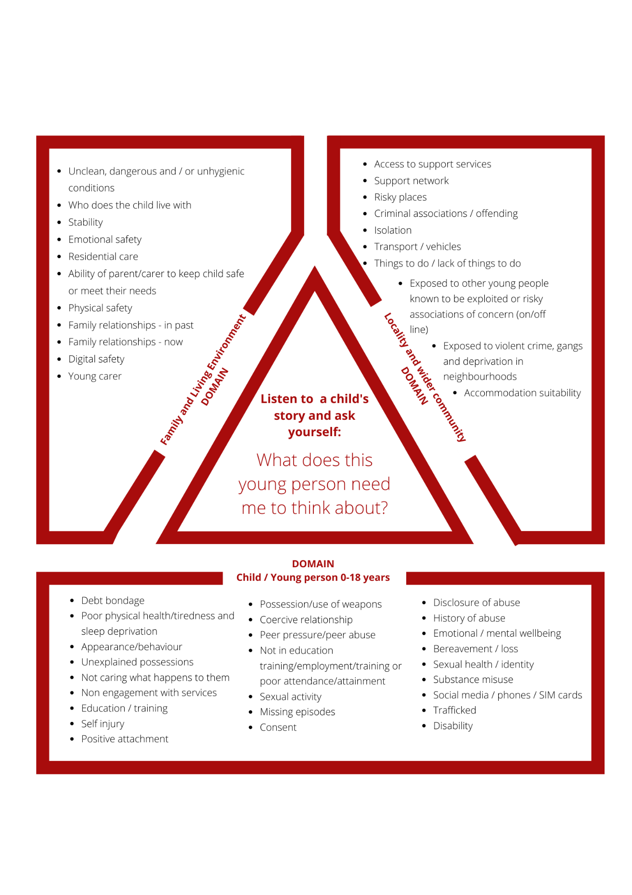

  - Outline of the reasons that have resulted in this CE Framework being completed

  - CHILD/YOUNG PERSON DOMAIN
Please comment on the relevant areas linked to the child/young person’s domain. Consider what creates the child’s vulnerability? Is there any evidence of child is being trafficked for the purposes of exploitation? What positive relationships and/or activities have you identified or are there any that could be developed?

Trafficking in persons’ shall mean the act of: Recruitment, Transportation, transfer, harbouring or receipt of persons. By means of: Threat, use of force, coercion, abductions, fraud, deception and abuse of power for the purpose of exploitation For more information in respect of Trafficking, please refer to the Warwickshire Safeguarding Trafficking procedures.

  - What do you need to know more about?

  - FAMILY AND LIVING ENVIRONMENT DOMAIN
Please comment on the relevant areas linked to the Family and Living Environment domain. Consider the impact of the child’s family environment on their needs and vulnerability. Consider protective factors that exist or need developing?

  - What do you need to know more about?

  - LOCALITY AND WIDER COMMUNITY DOMAIN (Contextual Risks)
Please comment on the relevant areas linked to the Family and Living Environment domain. Consider how do people, locations and other factors in the locality and wider community impact on the child’s needs and vulnerability? Consider protective factors that exist or need developing?

  - What do you need to know more about?

  - Child/Young Person views about the concerns

  - Parents/ Carer views about the concerns

- Assessment

What does this information tell me?

- Additional Information

Please use this box to expand on any additional information.

- Outcome

Based on the assessment above, please provide your professional opinion of risk or harm by selecting ONE of the boxes below.

Each outcome has possible next actions identified, however if in doubt, please consult with the Front Door to seek advice/ consultation.

CE currently not a factor at this time/concerns relate to age appropriate behaviours

- No further action required.

Evidence of vulnerability to exploitation

  - Consider providing Early Help/ Targeted Services to address the concerns
  - Consult with the Front Door for advice about Early Help.

Evidence of being groomed or targeted for the purposes of exploitation

- Refer to the Front Door, if the child does not have an allocated worker. Ensure a copy of this CE Assessment Framework is shared.
- If there is an allocated worker, share concerns with a copy of this CE Assessment Framework.
- If there is information relating to perpetrators- share with Front Door/ Allocated worker
- Share information/ concerns with the Police using the Police Intel Sharing Form

Evidence¹ that child is being exploited

- In the event that the child is in danger or you need an immediate police response, call 999.
- Refer to the Front Door, if the child does not have an allocated worker. Ensure a copy of this CE Assessment Framework is shared.
- If there is an allocated worker, share concerns with a copy of this CE Assessment Framework.
- If there is information relating to perpetrators- share with Front Door/ Allocated worker
- Share information/ concerns with the Police using the Police Intel Sharing Form

- In the event that the child is in danger or you need an immediate police response, call 999.
- Refer to the Front Door, if the child does not have an allocated worker. Ensure a copy of this CE Assessment Framework is shared.
- If there is an allocated worker, share concerns
- If there is information relating to perpetrators- share with Front Door/ Allocated worker
- Share information/ concerns with the Police using the Police Intel Sharing Form

- Additional resources:
Warwickshire Police- Intel Form
Warwickshire Police have devised a process to provide information about perpetrators and concerns of Child Exploitation occurring THAT IS NOT AN EMERGENCY AND DOES NOT REQUIRE IMMEDIATE ACTION (in these cases ring 999 or 101).

A copy of this form is available on Warwickshire Safeguarding procedures and by accessing the following link.
Further advice and guidance can be sought from the Child Exploitation & Missing Team as follows:
Via phone: 01926 684406
Email address: cemissing@warwickshire.gov.uk

The Front Door

Further advice and guidance can be provided by the Children and Families Front Door:

Phone: 01926 414144
Email: triagehub@warwickshire.gov.uk
Please ensure that a copy of the completed assessment document is sent to the above email address when making a referral.

You can also contact the Front Door to seek support around Early Help.

Training

Please visit the Warwickshire County Council Learning Hub if you would like to find out more about CE and Trafficking training in Warwickshire.

Something’s Not Right
Please click here to find out more information about Warwickshire’s CE awareness campaign.

On the balance of probability (more likely than not).

